VIETNAM NATIONAL UNIVERSITY OF HOCHIMINH CITY

THE INTERNATIONAL UNIVERSITY

SCHOOL OF COMPUTER SCIENCE AND ENGINEERING



**PROJECT REPORT**

**Internship IU**

By

Tran Hai Nam

Advisers:

Dr. Huynh Kha Tu

A thesis submitted to the School of Computer Science and Engineering

in partial fulfillment of the requirements for the degree of   
Bachelor of Information Technology/Computer Science/Computer Engineering

Ho Chi Minh City, Vietnam  
Year 2023

**Web app**

**Internship IU**

APPROVED BY: ________________________________ ,   
Tran Hai Nam – ITITIU19161

________________________________

THESIS COMMITTEE   
(Whichever applies)

Student Name: Tran Hai Nam. ID: ITITIU19161. Date of request: 3/10/2023

Cell phone: 0917417799

Advisor Name: Huynh Kha Tu. Semester: 1. Year: 2023-2024

|  |  |
| --- | --- |
| **TOPIC SUMMARY** | |
| **Topic** | **WEB APP FOR SUPPORTING INTERNSHIPS AT AN**  **INTERNATIONAL UNIVERSITY** |
| **Field** | **COMPUTER SCIENCE & ENGINEERING** |
| **Specialty** | **INFORMATION TECHNOLOGY** |
| **Keywords** |  |
| **PROBLEM DESCRIPTIONS** | |
| A website for support internships at international universities is a project to solve problems about students and teachers in internships. When I go to an internship at school the connection and interaction between student and school is less which leads to a problem student do not understand what they need to do in an internship at university. This project will solve that it also helps students can find jobs easier and teachers can manage all the students in this term.  General requirements:   * User authentication: Determine the user's roles and permissions on this website to provide appropriate functionality to the user.   - Filter and search: Functions to help users sort or search on the web  - Notifications: the website will send notifications to users when someone uploads, updates a new status, or makes an announcement from the university.  - Community tools: users supporting the website can connect with each other for better workflow. Third parties can be embedded to reduce resources.   * Design the system of website: Increase accessibility as well as handle load from multiple users at the same time and have the ability to upgrade and expand for the future.   Student**:**   * Display and register for jobs: Students can look up and register for jobs on the website and turn the status into notification for teachers to know and handle. * Information page: Students can check their own information to authenticate registration and enter scores later. * Company page: displays information about companies with job offers. * Apply and Register form is a page where students can send emails to apply for the job they want. * Jobs applied: displays jobs for which applications have been submitted. * Report page: page for students to get report forms and submit their reports to teachers for grading. * CV page: to register the cv you want to attach to job applications, there is a cv template available that can be created. * Job suggestions: based on students' data and information to suggest some jobs related to personality as well as job field... * Chat bot: supports students in answering questions related to process issues and gets information from students by asking questions and giving suggestions to help students find jobs more easily.   Teacher:   * Student management: Teachers can see student lists and information. * Grading page: teachers check student reports, enter grades for that student, and have the ability to export to a file to conveniently enter grades into the school's grading system. * Report page: teachers can take report templates and send their report files to the school to support office tasks for teachers.   Admin:   * Management: manage students and teachers during the internship semester, control information and notify each user. * Job management: add or remove existing jobs and change the status of jobs that no longer exist, etc. | |
| **WORK PLAN** | |
| First:   * Research and analyze to choose and use the most suitable technology for this web app project, choosing integrated solutions for the interface, server, data, ...   Second:   * Deploy and implement the front-end side to determine the user's workflow when using the web.   Third:   * Deploy and implement the backend Distribute data streams to optimize performance as well as information security.   Fourth:   * Deploy and test the system and design to help the system increase access speed and increase the number of users.   Finally:   * Summarize and write an application report about the applications and test runs. | |
| **Supervisor Approval**  **Approval Date:____________________.** | |

# ACKNOWLEDGMENTS

To complete the thesis, I have a lot of help and support from many organizations, agencies, and people to finish my thesis. Permit me to extend my most sincere appreciation to all organizations and individuals who have rendered themselves indispensable to me during the course of my studies and research on this subject.

I wish to convey my appreciation to Dr. Tu for affording me the chance to convene and collaborate on this subject matter. Furthermore, I am grateful for the extensive assistance provided by Dr. Tu in terms of guidance, strategizing, and addressing all of my inquiries. From the outset, his unwavering support has been important in broadening my horizons within this domain. Furthermore, I would want to express my gratitude to all of my acquaintances who provided me with support and aid throughout my academic pursuits.

Given the constraints of time and limited experience, it is inevitable that this thesis will have some weaknesses. I really anticipate obtaining valuable input and feedback from all individuals to enhance and optimize next practical endeavors.

# TABLE OF CONTENTS

ACKNOWLEDGMENTS 6

TABLE OF CONTENTS 7

TABLE OF FIGURES 9

CHAPTER 1 10

INTRODUCTION 10

1.1. Background 10

1.2. Problem Statement 10

1.3. Scope and Objectives 10

1.4. Assumption and Solution 10

CHAPTER 2 10

LITERATURE REVIEW/RELATED WORK 10

2.1. Related App 10

2.2. Student requires 11

2.3. Dashboard: 12

2.4. Teacher requires 12

2.5. Admin 12

2.6. Design System: 13

2. 13

2.6.1. Use case diagram: 13

2.7. 13

2.8. Main Workflow 14

CHAPTER 3 15

METHODOLOGY 15

3.1. Overview 15

3.2. User requirement analysis 15

3.2.1. Overview 15

3.3. System Design 15

3. 15

3.3.1. Database design 15

3.3.2. User Interface design 15

CHAPTER 4 15

IMPLEMENT AND RESULTS 15

4.1. Implement 15

4.2. Results 15

CHAPTER 5 16

DISCUSSION AND EVALUATION 16

5.1. Discussion 16

5.2. Comparison 16

5.3. Evaluation 16

CHAPTER 6 16

CONCLUSION AND FUTURE WORK 16

6.1. Conclusion 16

6.2. Future work 16

# TABLE OF FIGURES

Figure 1: Example for jobs list 6

Figure 2: use case diagram 8

Figure 3: Workflow 9

Figure 4: login page 10

Figure 5: User information page 11

Figure 6: Home page of students 11

Figure 7: Modal of job view 12

Figure 8: Jobs page 12

Figure 9: company page 13

Figure 10: Apply form. 13

Figure 11: Display jobs applied page. 14

Figure 12: Register job form 14

Figure 13: Register instructor form 15

Figure 14: Report page 15

Figure 15: Home page of Teacher 16

Figure 16: View Student 16

Figure 17: Announcement form 16

Figure 18: Grading form 17

Figure 19: Grade view page 17

Figure 20: Report page 18

Figure 21: Manager User 18

Figure 22: Manager companies 19

Figure 23: Manager Jobs 19

# ABBREVIATIONS

IU: International University

NPM: Node package manager

RDBMS: Relational Database Management System

MUI: Material UI

# CHAPTER 1

# INTRODUCTION

## Background

An internship is a brief work placement provided by businesses and other organizations to individuals, typically students but not always, to provide them with some initial exposure to a specific industry or subject. It is work as much as it is an educational experience. Interns should ideally work on pertinent projects, learn about the sector, network with other professionals in the field, and hone their hard and soft skills. Sometimes internships even result in offers for full-time jobs. (Zhang, 2020)

Some benefits of internship:

* Experience real work and gain experience: The process of experiencing real work in the working environment at different companies helps students understand business requirements and develop professional skills. (LEADERONOMICS, 2022)
* Make Student CVs look better: The Project and work students do in the internship that the key to impressing future employers and helping them stand out from other applicants. (LEADERONOMICS, 2022)
* There are more connections with those in the student’s field of profession: Internships are a great opportunity to expand connections for students in a professional environment. This helps students a lot in finding jobs after graduation as well as in furthering their studies later. (LEADERONOMICS, 2022)

Some cons of internship:

* Internships can be unpaid work: Internships are a great way to get your foot in the door in the industry you want to work in. However, some internships are unpaid, and it would be difficult for students to work without receiving any compensation or payment for the internship. tourism. and food expenses. (LEADERONOMICS, 2022)
* Internships affect your studies at school: Internships can cause you to fall behind in your university studies because of disagreements about time and location, which takes a lot of time and effort to travel, especially internships also add pressure to students. (LEADERONOMICS, 2022)

Based on the benefits having a greater impact than the disadvantages of internships, internships have become a subject and a requirement for graduation for students at today's universities.

## Problem Statement

At international universities, internship is a mandatory subject and is considered a mandatory condition for students to graduate. However, the school's internship process has many difficulties, making it difficult for many students to register for internships as well as find internships even though the school has information sites to support this such as IU Job hub, job Fair, ... Most of the difficulties that make it difficult for students to intern at university are that the IU's information channels are too numerous and unfocused, making it difficult for students to recognize what is important and urgent for the internship, and missed time and had to miss the internship. The post-Covid impact on the economy has created a strong wave of lay-offs. This wave in 2023 has increased significantly compared to 2022, which has left a large surplus of high-quality employees. and reduces the need for businesses to intern. At the same time, finding internships as well as connecting and exchanging between students and teachers is still limited. These things have caused several students to drop out of school internships recently, leading to a slowdown in graduation and learning progress.

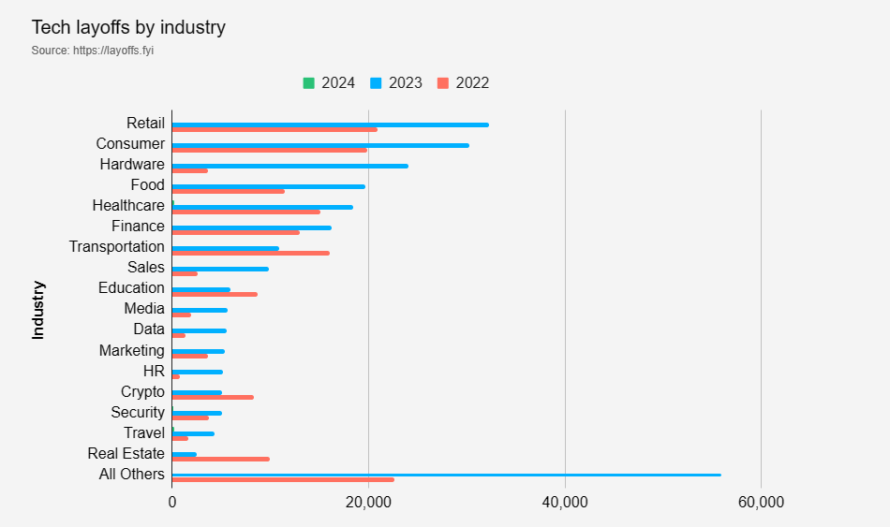

Figure : Layoff situation of industries by (layoffs.fyi, 2023)

There is a lack of a dedicated system to support teachers in observing and helping students during their internships. This shortage leads to delays in disseminating information, finding potential jobs, managing students without internships, and hindering the development of student's educational and career potential.

This project was carried out to solve these problems by designing and building an internship website system for the International University with a friendly, intuitive interface for students and teachers, thereby promoting communication and connection between businesses, teachers, and students. Successful development and implementation of the project is expected to optimize the internship process, bringing the best support results for students' internship process as well as management work for teachers.

## Scope and Objectives

### Scope

The scope of the project includes the implementation and development of a website to support students and teachers during the internship process.

This website will help facilitate connection, information sharing, and management. Scope includes:

* User segmentation: The website will meet the needs of each student, teacher, and website manager.
* Dissemination of information: The system will enable effective sharing of information, guidance, and resources related to internships.
* Accessibility: Ensure it is accessible to a wide audience across popular web browsers and mobile devices, ensuring broad usability.
* Task management: Implement features that support assignment, tracking, and management of internship tasks for both students and teachers.
* Connectivity: Provides tools for effective connection between students and teachers, fostering an environment conducive to instruction and feedback.

### Objectives

Main objectives of the Internship Website Support project:

* Ensure security and privacy: Implement robust security measures to protect sensitive information and ensure user privacy.
* Streamline the internship process: Create a clear and visual internship workflow. Make it easy for students and supervisors to track and manage internships.
* Simple interface: Design a simple and user-friendly interface that accommodates users with varying levels of technological proficiency.
* Scalability: Design the system to accommodate future growth and changing user needs by easily adding new features.
* Evaluate user experience: Continuously gather feedback to improve the application.

## Assumption and Solution

### Assumption

The website was built and developed with the purpose of supporting teachers and students during the internship process at IU, so there are some assumptions as follows:

* The website must be easy to see, and the pages must be intuitive and easy to navigate for each task for students and teachers.
* The website must be diverse and full of different features and resources for each user with different roles such as teachers, students, and admins.
* The website can be easily accessed via the internet with the most popular devices today.
* The website must solve the problem of continuous test tracking for teachers and students.

### Solution

Some solutions for website projects:

* Use minimalist designs for easy operation by students and teachers.
* Create functions to support exchange and connection between teachers and students.
* Create support functions for students during the internship process such as adding CVs, writing reports, ...
* Resource library with downloadable documents
* Create functions to help teachers easily observe and manage students during practice, such as progress tracking, etc.
* Promote the website to students and teachers through social media, email marketing, and other channels.

# CHAPTER 2

# LITERATURE REVIEW/RELATED WORK

Internships are a crucial and essential component in helping students apply their professional knowledge to the workplace and close the knowledge gap between academic study and real-world professional experience. As a result, to provide guidance, the website system that supports the internship process for teachers and students at international universities must investigate and evaluate the obstacles and problems that these parties encounter and develop various approaches to resolving those issues.



## Existing Platforms for Internship Support

Several platforms have been developed to address the difficult challenges of internships.

### Glints

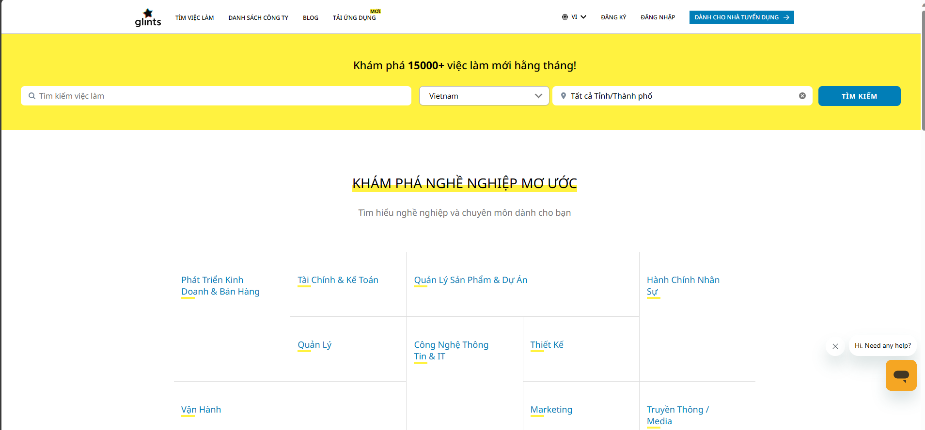

Glints is one of the leading job search platforms in Southeast Asia established in 2015 in Singapore and has supported more than 5 million talents and more than 60000 organizations (glints, 2015). Like most other job search platforms, there are functions to assist users in the job search and application process:

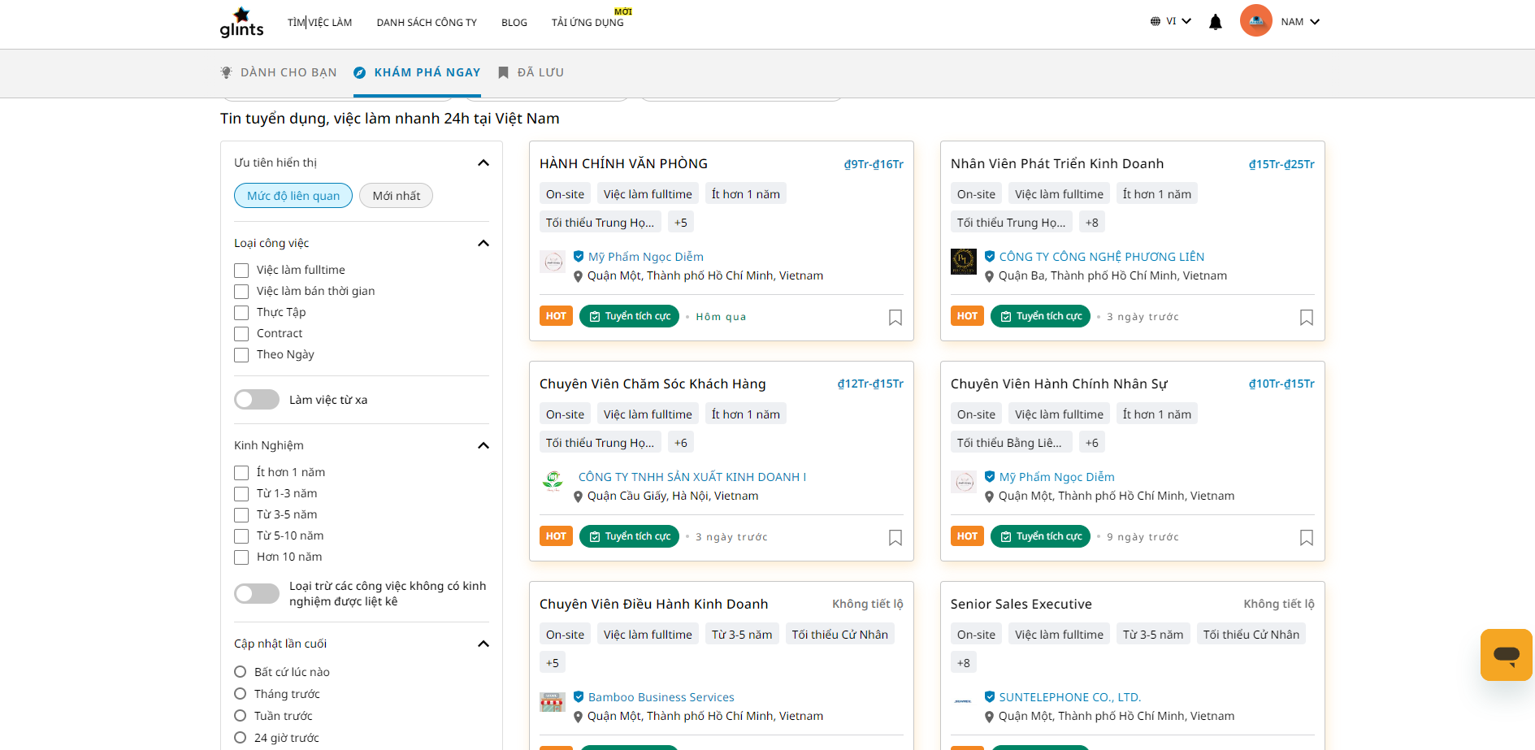- A special, intuitive interface is designed to help users easily grasp information about each job and company.

-There is a recommendation feature based on keywords about the job field that the user wants when initially registering.

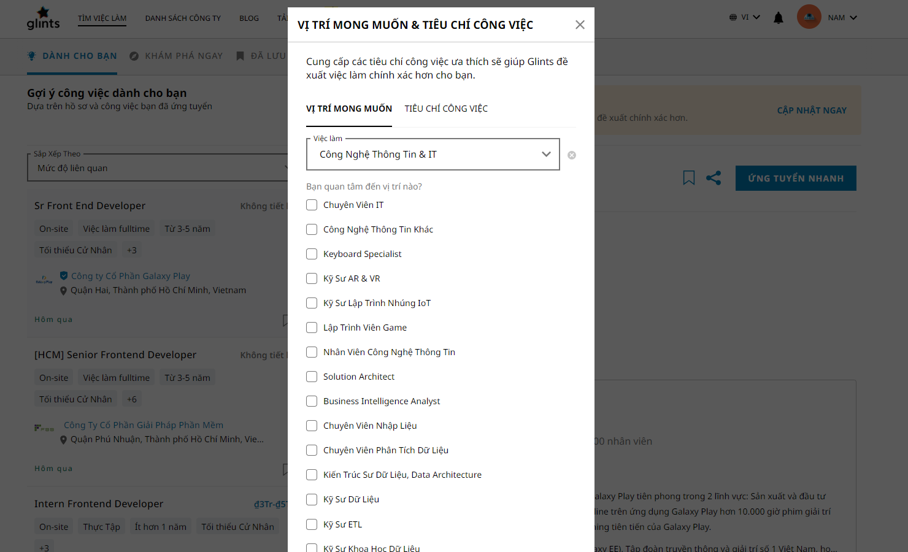

- Enhance and support users' job application work has a notification feature and checks the application process according to different statuses, for example, CV review, interview, qualification test, receive.

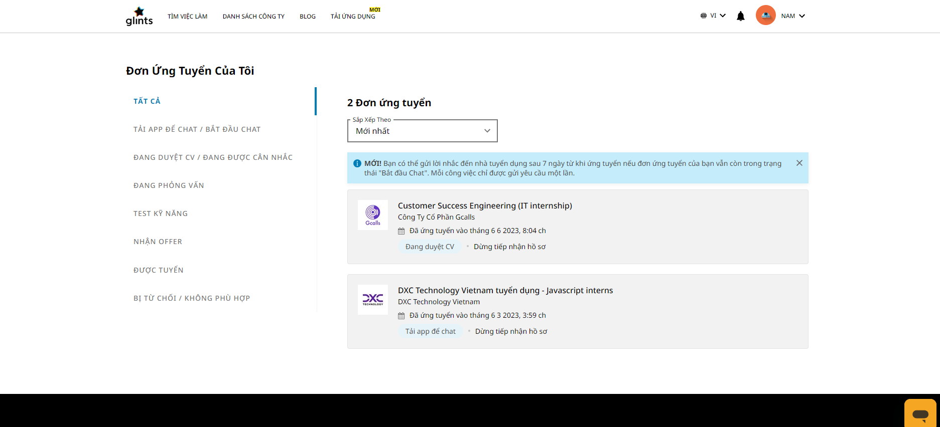

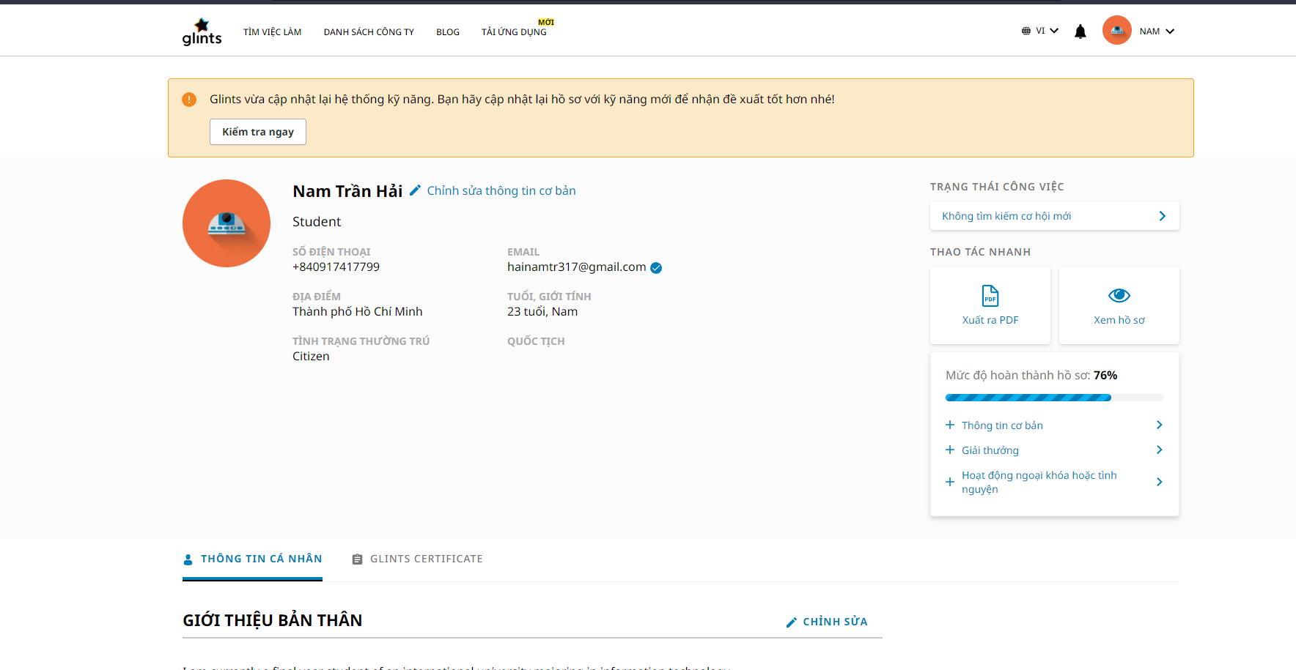- Ability to customize personal information: Profile information for applying can be freely customized to help users express all the necessary information to employers.

### LinkedIn

LinkedIn is the world's largest professional network, with more than 1 billion members worldwide, which was founded in 2003 (LinkedIn, 2003). The platform was developed to connect professionals across industries, find jobs, and User's career development.

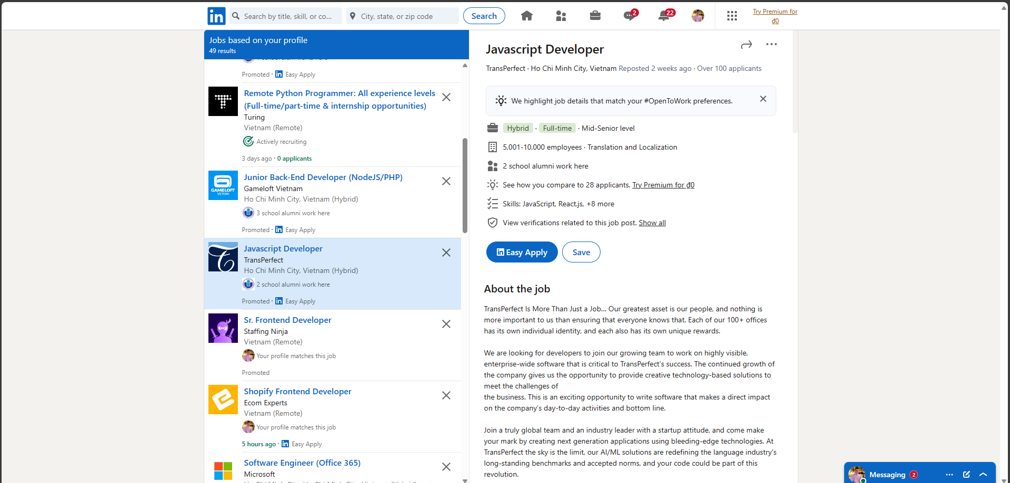

Some stinging aspects of LinkedIn:

* Sharing information and content: Users can freely share articles, videos, personal emotions, etc. with people connected to them on the network.
* 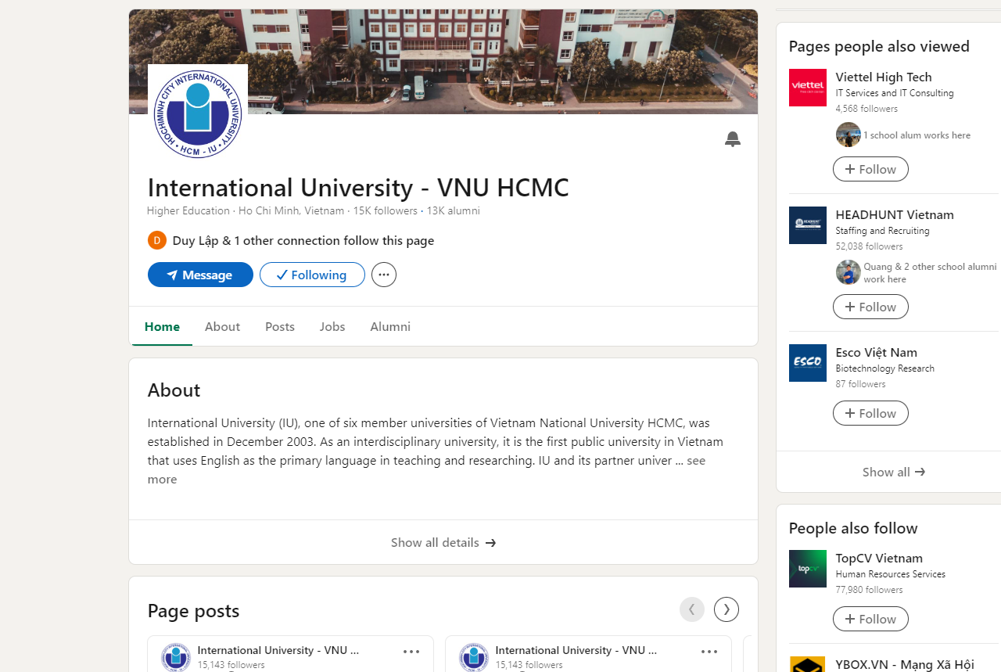Create Profile and Company Pages: users and businesses can freely create personal pages with a variety of information such as education level, work experience, skills, recruitment information, etc.
* 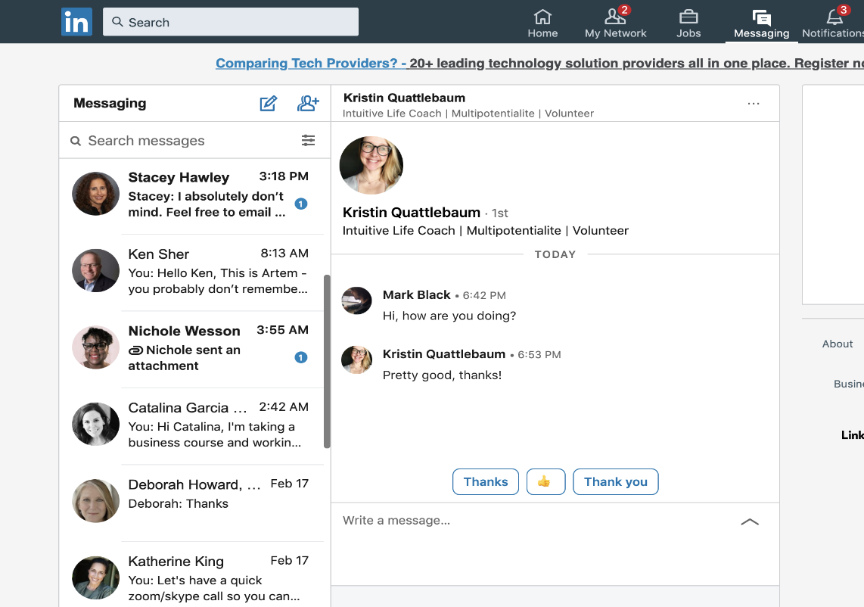Communication: Users can communicate with their connections through LinkedIn's messaging system. This is often used for professional inquiries, employment opportunities, or collaborations.
* 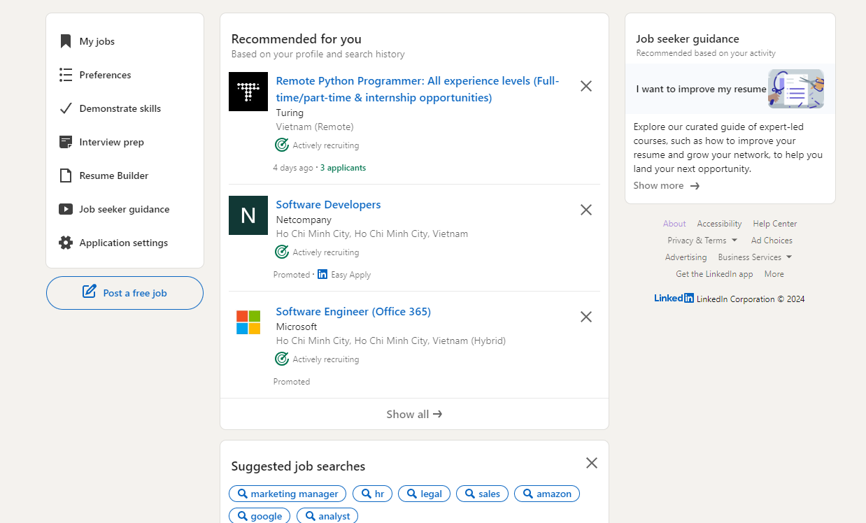Job search: LinkedIn allows businesses to post information about the jobs they recruit and users can search and find the desired job through it.

### IU Job Hub

IU Job Hub is an information portal that shares and connects international university job issues.

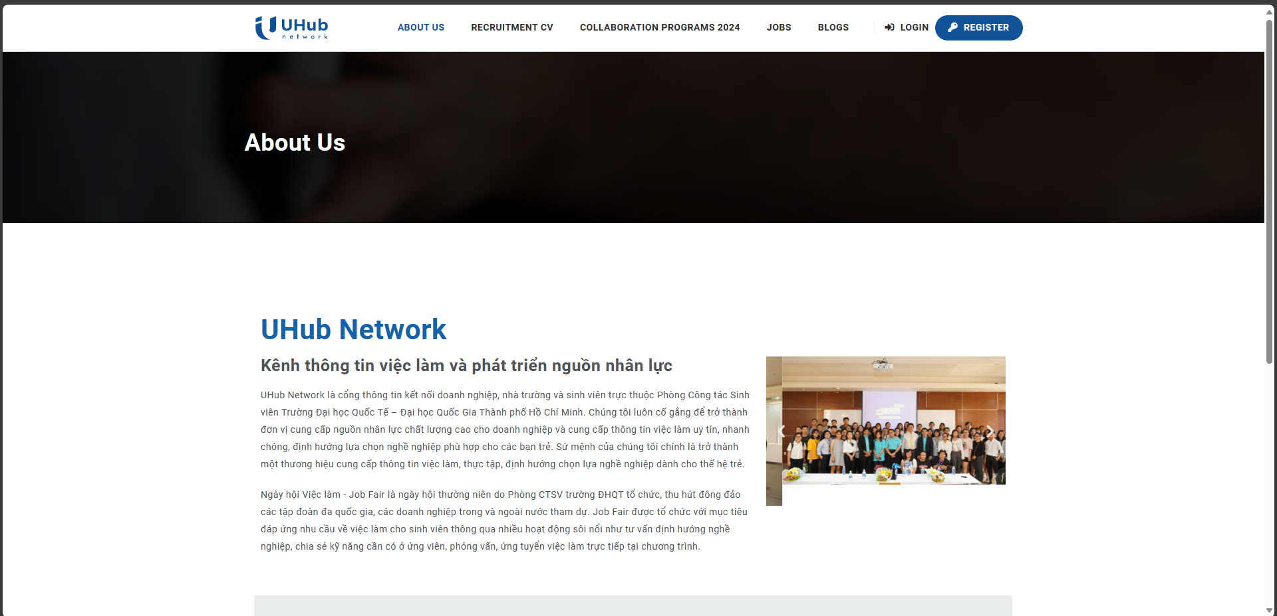

There are some basic and outstanding functions as follows:

* 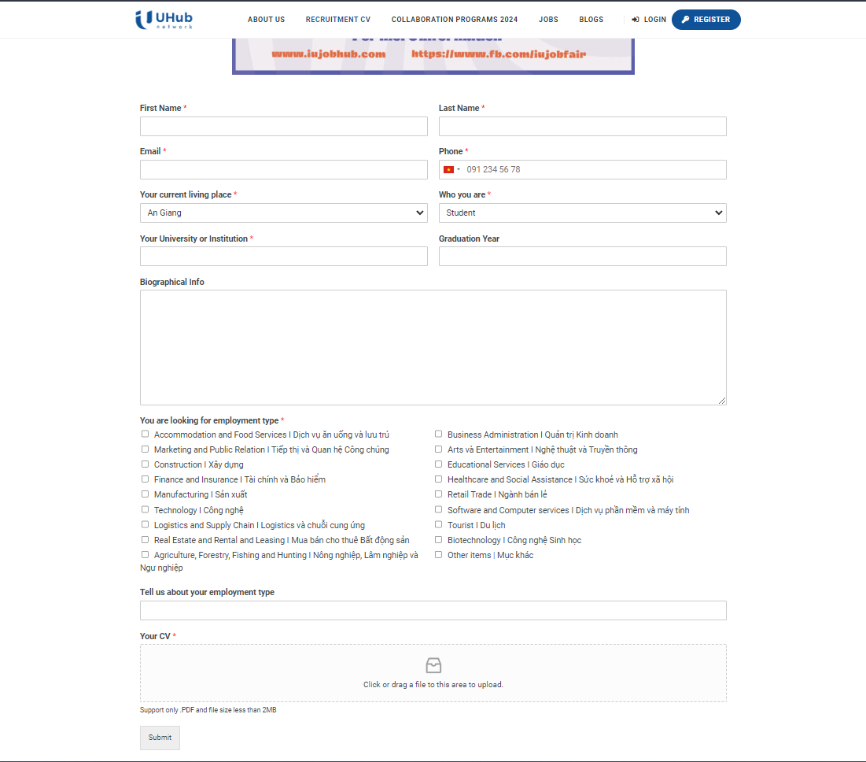Recruitment CV: Used to register information to send to employers.
* 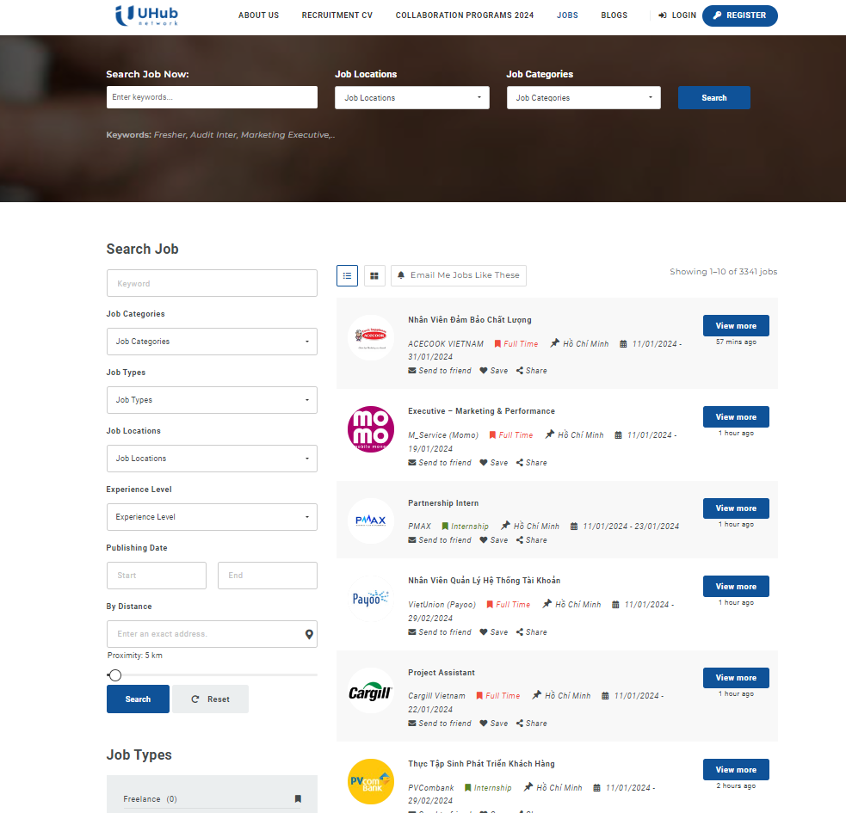Find Jobs: Platform that allows you to search and apply for jobs with a simple, intuitive interface.
* 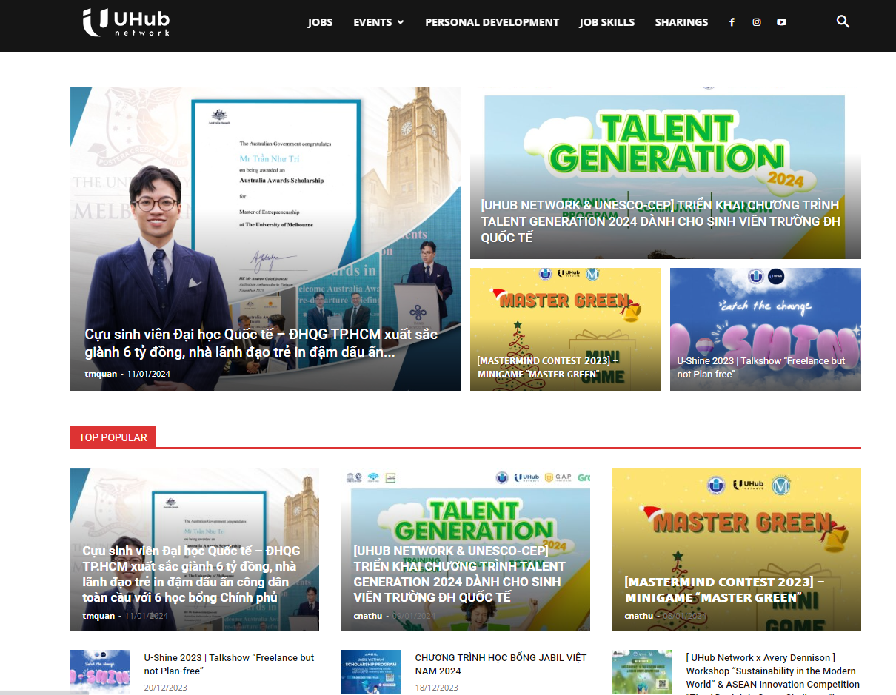Blogs: The platform also shares festivals as well as program information of businesses connected to international universities.

### Analysis and Evaluation

A brief review of the mentioned functions of these currently available platforms, although very complete in many aspects, however for this project, it only meets the needs of finding jobs for students, with Support for the ability to connect teachers, students, and businesses, but assessment management is not yet available to support teachers.

## Challenges of students during the internship process.

Internships are an opportunity for students to experience and interact with social reality, thereby gaining more experience in professional and personal development after graduation. Along with that, the internship process of students in general and IU students in particular has different difficulties.

### Difficulty accessing information sources.

At IU there are many different sources of information, both official and unofficial, such as BLACKBOARD, Edusoftweb, job Hub, Facebook fan page, ...

 

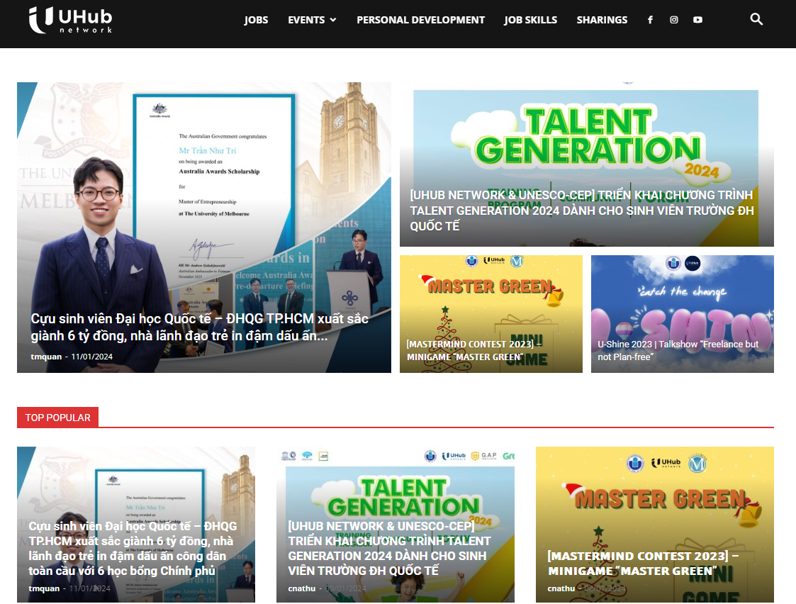 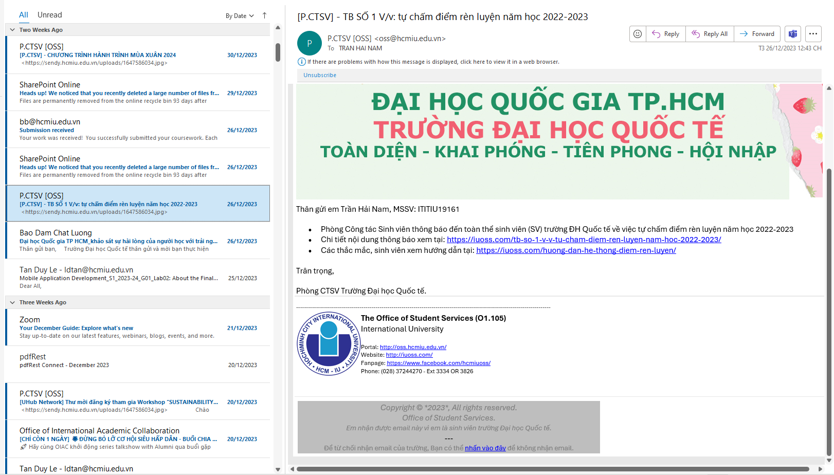

It is the diversity of information sources that makes finding experiences or internship processes at school more difficult and unreliable. Students lack the necessary information to prepare for the internship process, which can prevent students from being able to prepare and keep up with the school's set schedule and the school's regular internship period. It takes place in the summer very quickly, only about three months to complete everything from finding an internship to submitting a report. So this project is to develop a platform that can centralize information into a single official information page that shares the school's internship process so that students can be thoroughly prepared for the internship at IU.

### Difficulty in finding internships.

According to the analysis in the article UEH's student care and support department, ((DSA), 2023) the impacts of post-COVID as well as the current stressful situation in the European region have had a strong impact on the economy. The impact and wave of layoffs is strong everywhere in the world, including Vietnam, which is also affected, causing a surplus of highly qualified labor and that creates difficulties for students who want to Intern as well as students about to graduate who do not have much experience. To solve that, the school should also have business connection programs to support students with more opportunities in finding internships and this platform will be a bridge to support students in finding internships. there.

### Lack of soft skills and connection with teachers

Some necessary skills for students to be able to find jobs such as writing CVs, sending emails, interviewing... students often lack these necessary skills to be able to apply for jobs. However, the most difficult thing is to determine the certainty of those skills so that students can confidently apply themselves for the jobs they want. This requires the support and confirmation of the teacher. she instructed. A platform that provides knowledge information for these skills and connects students and teachers so that teachers can support and validate student progress is a necessity.

## Teachers' disadvantages and difficulties in supporting students.

Teachers at IU have difficulty managing students because they lack a platform to track student progress during the internship process so they can proactively support students. Some processes teachers need to support students include finding jobs, writing CVs, and writing reports.

The teacher's grading process also has difficulty synthesizing and checking each person's progress.

A platform that supports teachers in these processes is something that can reduce the workload and pressure on teachers, thereby helping teachers better support students and improving work productivity for teachers.

## Security and privacy concerns in educational support websites.

The rapid development of technology comes with the risk of personal information being exposed, and a survey found that 82% of people shared that the organization they work for has experienced at least one data breach digital conversion (Tùng, 2022).

Therefore, applying security features is necessary and a priority for every platform today.

Authentication issues with all access, minimizing third-party support, etc. are necessary issues for the platform to avoid the possibility of outsiders entering the system and stealing your data. students and teachers for personal gain.

## JavaScript for web development



JavaScript is a powerful programming language for website development invented by Brenda Eich. (hamiswillee,Cybersharph , 2023). The survey shows that JavaScript is considered the most popular language, used by many users 63.61% compared to other languages. (stackoverflow, 2023).

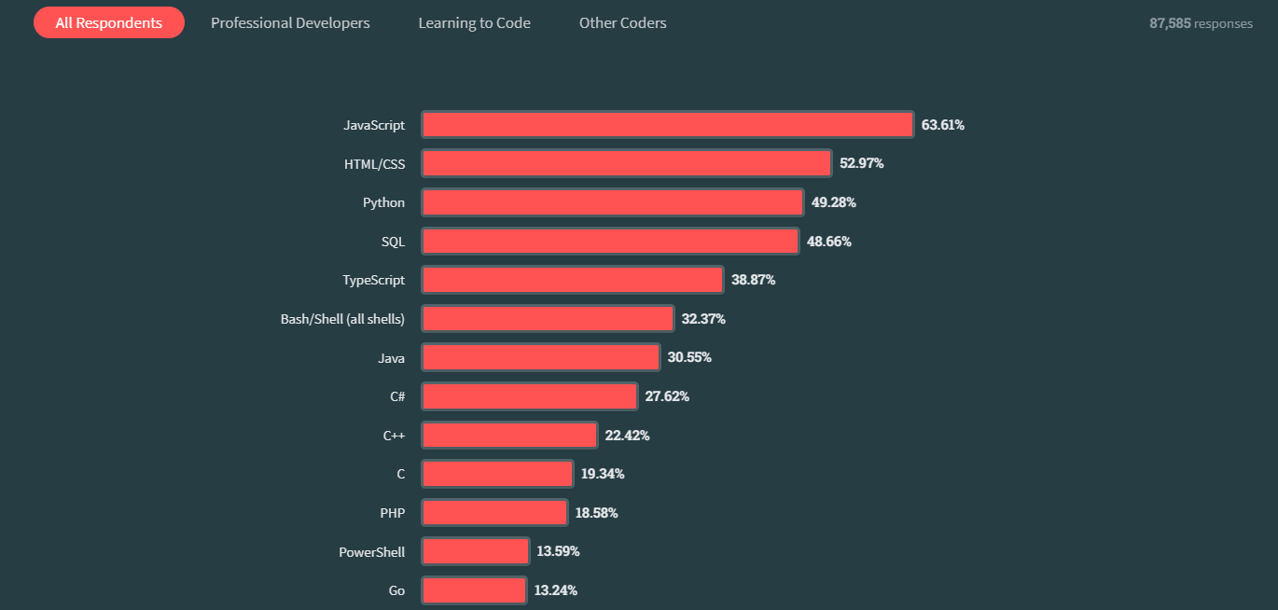

JavaScript is a language used to develop websites with JS that can turn a static website into a dynamic website with different functions. JavaScript supports many programming paradigms such as object-oriented, procedural, and functional programming. Some concepts and capabilities in JavaScript such as closures, primitives, and asynchronous programming are elements of JavaScript, which makes JavaScript popular in web programming.

About Frameworks and Libraries:

JavaScript has a long history of development, so there are many different frameworks and libraries to assist in website development. Some outstanding support frameworks and libraries include:

Front end: React, Angular, Vue.js

Back end: Nodejs, express,

JavaScript for web development shows its dynamic evolution from a scripting language to the foundation of modern web applications. Researchers and developers continue to explore features, and best practices, and expand its ecosystem, providing valuable insights to developers in the ever-changing web development landscape.

## Nodejs



NodeJS is an open-source JavaScript runtime environment and does not depend on any operating system so it can be developed on any type of computer on the market today (Semah, 2022). Nodejs is often used to run and build backend systems due to its several advantages:

* Asynchronous event-driven IO, allowing multiple requests to be processed concurrently.
* Use JavaScript – an easy-to-learn programming language.
* Allows streaming of large files
* Actively supportive community

## Node package manager (npm)



Npm is a tool that comes with NodeJS that manages packages, supports installation, downloads libraries to support system development using NodeJS, and registers and creates NodeJS projects for developers (Metwalli, 2023).

Some of the benefits npm brings to users:

* Reusability: Being open source, anyone can use any package on npm to build personal projects.
* Support: Since there are so many developers using npm, this can also be a co-development community from which support users can help each other manage bugs and develop.
* Dependency management: It is a way to handle and manage dependencies effectively when working on large projects, especially when developers don't live in the same country.

## Express.js



Based on the content in the shared article (Sharma, 2023). Express is a NodeJS-based framework that provides built-in functions to support building applications for web and mobile devices.

Express features provide great support in backend network development, for example:

Middleware: Middleware is a request handler that has access to the application's request-response cycle.

Routing: refers to how the URL of an application's endpoint responds to client requests

Debugging: Express makes this easier because it pinpoints the part with the error

How Express Works:

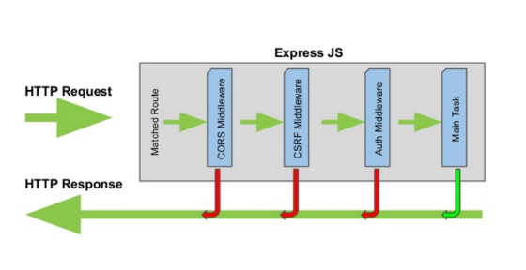

Through a comparison of how taking orders in a restaurant operates, we provide an express operating process that can be understood and used for backend development (Kononenko, 2017). The way express works is to receive requests to perform server-side functions that the client side puts through screening steps that return different results to the client.

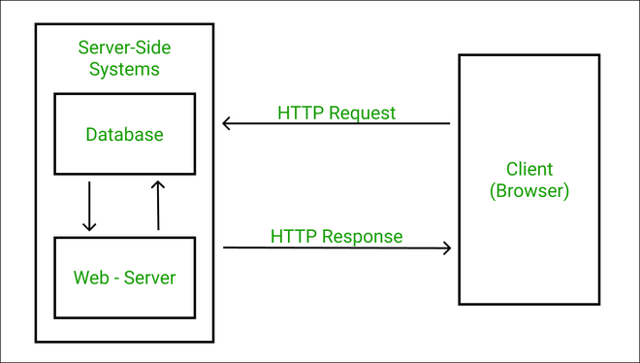

## Vite



Vite is a tool that helps developers create and grow new projects and solves some of the challenges in front-end web development with the following features (Refine, 2023).

* Support for native ES modules: Vite improves overall performance allowing for fast startup and increased storage capacity based on the characteristics of the native ES module instead of having to package the modules during development Vite uses the browser's native capabilities to load native modules as separate files (Refine, 2023).

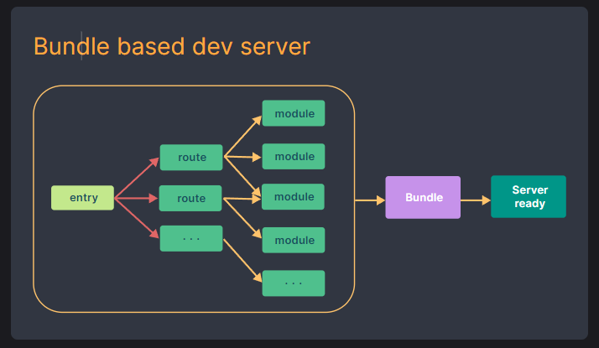

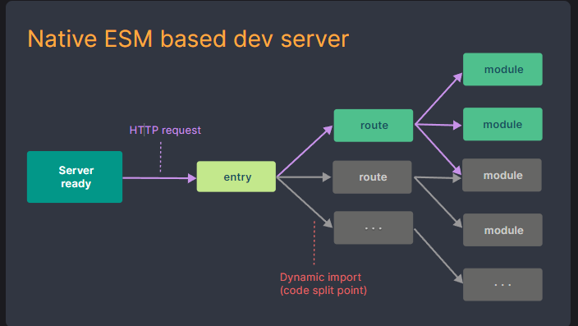

* Fast build process: ‘esbuild’ is famous for its outstanding speed, capability of creating optimized encoding packages, and fast packaging ability compared to traditional packaging, which Vite takes advantage of to help with deployment productivity (Refine, 2023).
* Code separation and lazy loading: Vite supports code separation and lazy loading. This helps the system to only load the necessary content and load separate parts, thereby reducing loading time and increasing user experience (Refine, 2023).
* Hot Module Replacement (HMR): HMR can track changes in the model and replace it while the application is running without having to reload all the application's modules. (Refine, 2023)

## React



React is an open-source library developed by Facebook to support front-end development, used by large technology companies for Facebook, Netflix, WhatsApp, etc (Hai G, 2020). Some features of React help the library to be chosen by up to 40.58%, ranking second in the survey after NodeJS (stackoverflow, 2023).

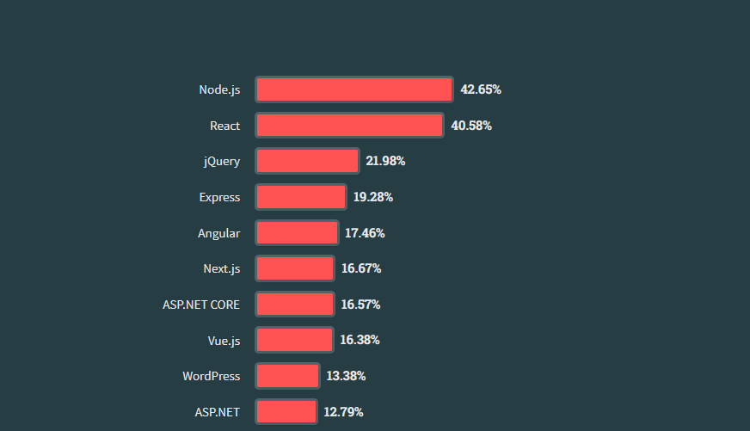

Easy to use and learn: React is an open-source code developed from the JavaScript language, so just knowing about JavaScript is easy to use and access.

Reusability: React has a special structure that allows developers to reuse components, thereby reducing the workload for developers.

## MongoDB



MongoDB is an open-source NoSQL database used for storing large amounts of data. NoSQL Instead of using tables and rows as in the traditional relational database of SQL database, MongoDB uses Use collections and documents (Pedamkar, 2023).

MongoDB has the similar structure as RDBMS, a commonly used database structure, and uses the BSON format to store documents. (Pedamkar, 2023)

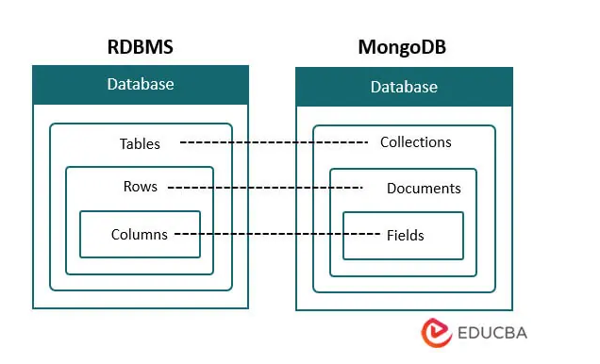

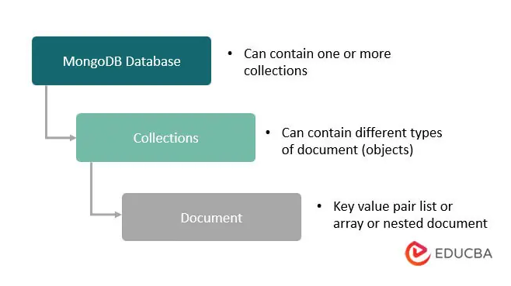

Some application functions use MongoDB:

* Real-time differentiation: MongoDB has a low delay per second which allows data analysis to be updated and tracked quickly (Pedamkar, 2023).
* Product Catalog: with a dynamic schema that allows for accurate filtering of keyword-related records (Pedamkar, 2023).
* Scalability and dynamics: MongoDB can store a variety of data in different forms to help the subsequent development of the application in having to collect data from a variety of sources (Pedamkar, 2023).

## Material UI(MUI)

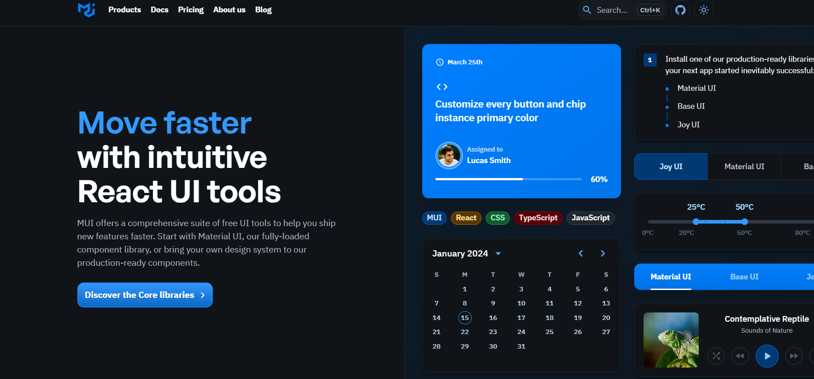

MUI is an open-source library of React components supporting the design and construction of the interface (UI, 2023).

Some advantages of MUI (UI, 2023) :

- Beautiful by default: Developed and design recognized over the years guaranteeing conformity to the standards of form.

- Customization: Allows customization of the walls according to personal preferences to have distinction in the applications of the developer.

- Reliable community: MUI has a long history of development in the React ecosystem so MUI's collaboration is very confident in supporting and developing.

## What On Earth Is Redux & Why Should I Consider It For My React App? | by Lukonde Mwila | MediumRedux

Definition:

“**Redux is a pattern and library for managing and updating application state, using events called "actions".** It serves as a centralized store for state that needs to be used across your entire application, with rules ensuring that the state can only be updated in a predictable fashion.” (Redux contributor, 2023)

In a large program there will be many different application states in many different places that need to be exchanged to get information from each other or continuously updated states then Redux is the most effective solution to solve those problems.



How redux works

At the user interface provide actions to perform redux actions designed by the developer to send new data changes that need to be updated. When this updated state arrives at the storage area, it will take the same state assign a new state change, and then update the data to the interface.

## Axios



Axios is a JavaScript library that supports sending HTTP requests from a server or web browser (Kollegger, 2018).

Axios functions:

* Create XMLHttpRequest and HTTP requests.
* API support promised.
* Automatically handles Json data conversion.
* Setting bandwidth limits

## Docker



Docker is a platform designed to make it easier to create, deploy, and run applications using containers. Containers allow developers to package an application with all the parts it needs, such as libraries and dependencies (Dokcer, 2023)

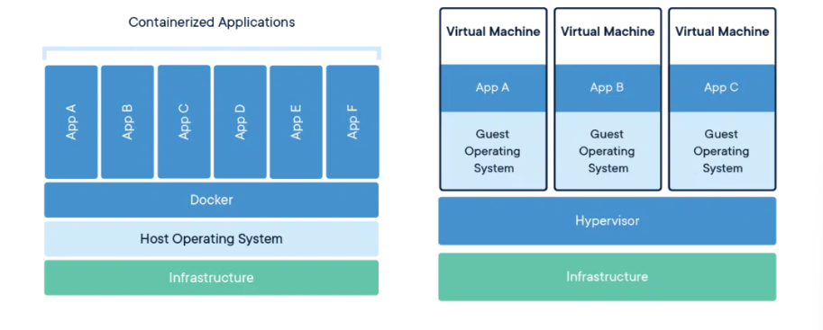Docker is a new way to change the way large system programs are run. Instead of having to create different virtual machines with separate operating systems that take up a lot of resources and space, docker shares the machine's operating system kernel, making the system lighter and easier to manage while reducing error rates. due to different machine environments.

### Container

A container is a standard unit of software that packages code and all its dependencies so that an application runs quickly and reliably in any number of different machine environments. The conditions and components to run the application such as code, runtime, system tools, libraries, etc. are packaged into a Docker engine image. (Docker, 2023)

## JSON Web Token

An open standard called JWT (JSON Web Token) (Poddar, 2022) offers a standardized way for data to be safely and consistently transferred between parties using JSON objects. Authentication and authorization in online services and apps are among its main use cases. The three primary components of a JWT are the Header, Payload, and Signature. Information about a JWT's type and the cryptographic algorithm—such as RSA or HMAC—used is contained in the header. The data to be delivered, such as user details, access rights, and other optional data, is stored in the payload.

Encoding is commonly used in JWTs to transform data in both the header and payload portions. If users have access to JWT, they can easily decode the encrypted data to obtain the original information. It is therefore advised to refrain from putting sensitive information in these parts. The data is not meant to be encrypted or secure by the JWT encoding method, such as Base64Url encoding. Its primary goal is to guarantee the token's efficient and reliable transfer. It makes it possible to express binary data in a way that makes it transferable between various systems with ease. Last, the Signature is a string created by utilizing a secret key specific to the token to sign the Header and Payload. Verifying the integrity and authenticity of the token is the goal of the signature.

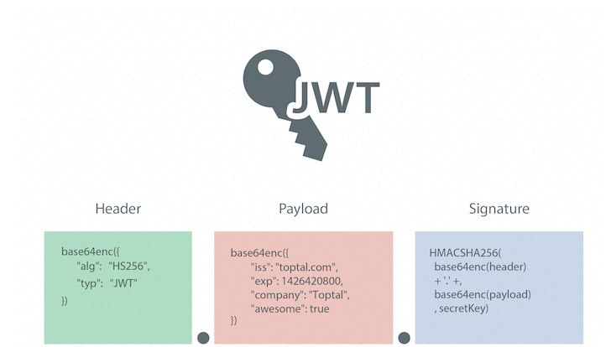

The workflow with JWT typically involves the following steps. Users log in with their credentials (username, email, password, and so on). The server verifies the login information and generates a JWT (JSON Web Token), which is then sent back to the user. The user includes the JWT in the Authorization header of subsequent requests to the server. Upon receiving a request, the server verifies the authenticity and integrity of the JWT by checking its signature and decoding the payload. The server utilizes the information in the payload to authenticate and authorize the user, granting access to the requested resources or services.

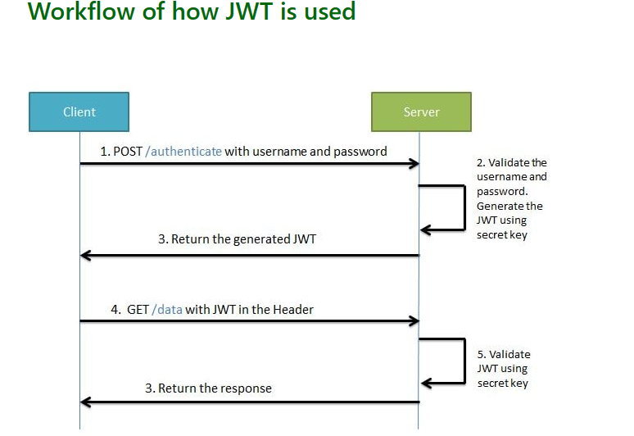

## Conclusion

In summary, the literature review established a solid foundation for the Web Support Internships for Students and Teachers project. By integrating insights from existing research, the project not only aligns with established best practices but also demonstrates a forward-looking approach, positioning it as a promising effort poised to make significant contributions to the field of educational technology and internship program optimization.

# CHAPTER 3

# METHODOLOGY



## Overview

Through analyzing the internship process from the beginning and end at the international university to provide reasonable and practical solutions to handle and support students and teachers, thereby can improve productivity.



## Requirement analysis

### User requirements



### Student requirement analysis

User Authentication and Authorization: Create a Login page. The student accesses the web use their student account and web app will redirect to student page.

Jobs list: The website should have a list of internships available for students (This will show in center home page), which should include the job title, company name, job description, location, and application deadline.

Company profiles: The website should allow companies to create a profile, which should include information about the company, its mission, vision, and values, and a list of current jobs they hire.

Communication tools: The website should have a built-in communication system that allows students and companies to communicate with each other regarding the application process. The students can also communicate with their teacher and instructor on this website.

Writing Curriculum Vitae (CV): The website supports creating CV forms for students to fill out and save in the system. Students also upload their personal CV on page CV.

Application process: The website should allow students to apply for internships by submitting their CVs and cover letters. The application should also include a form that captures the student's personal details such as name, email address, phone number, and educational background.

Notifications: The website can send notifications to students when a new internship is posted that matches their preferences and notify companies when a student applies for one of their internships. The website also sends notifications to teachers when students change their status of having received or completed an internship.

Chat: The website provides a chat method for students to communicate with their teacher and instructor.

#### Teacher requirement analysis

User Authentication and Authorization: The teachers will use accounts which are provided by the school to login to this web app.

Manger Student: The website supports Teachers to see all the students they manage. Teachers can visit the student page to view their CVs and make suggestions for students' CVs.

Dashboard: The website should provide a dashboard for students and teachers to keep track of student’s applications and the status of their applications.

Grading: During the time before the internship period ends, the website will send a notice to students for students to submit internship reports and teachers based on that to give student grades. Websites have a page for Teacher view again and edit after that they can export it to submit for school.

Notifications: The website will send notifications to Teacher when the students apply a job or register their instructor.

Chat: The website will provide a chat box for teachers to communicate with students.

Report form: website also provides list of report form for teachers make report.

#### Admin requirement analysis

User authentication and authorization: The admin must use an admin account to be able to log in and use website functions as an administrator.

Dashboard: The management page needs to see all information most intuitively, this helps a lot in management.

User management: The admin is the person with the highest authority so can monitor and control users. Has full functions such as adding, deleting, editing, etc.

Content management: All content displayed on the admin website must be able to be added or modified.

### System requirements

For a website to be used comfortably in schools, not only the software but also the hardware to run the website needs to meet the following requirements:

Server Hardware:

* Processor (CPU): Multi-core processor with high clock speed to handle concurrent requests efficiently.
* Memory (RAM): RAM is enough to support the load and avoid bottlenecks when the number of users increases.
* Storage: Use fast and reliable storage, such as SSD, to ensure quick data retrieval.

Scalability:

* Load balancing: The system should implement load balancing to distribute traffic evenly among multiple servers.

Security Measures:

* Security System: Deploy a firewall to filter malicious traffic and secure servers from cyber-attacks.
* SSL/TLS: Uses security protocols for data transmission, such as HTTPS.

Network Configuration

* High bandwidth: Ensure enough network bandwidth to handle incoming and outgoing server traffic.

Backup and Recovery: Implement automatic data backup function to avoid losing student and teacher data systems.

Web Server Software: Choose the right type of management software to increase system performance.

## System Design



### User Interface design

#### Use case diagram.

Based on some requirements and analysis of the website. The Internship IU web app will have 2 main actors are students, teachers and extra actor is admin.

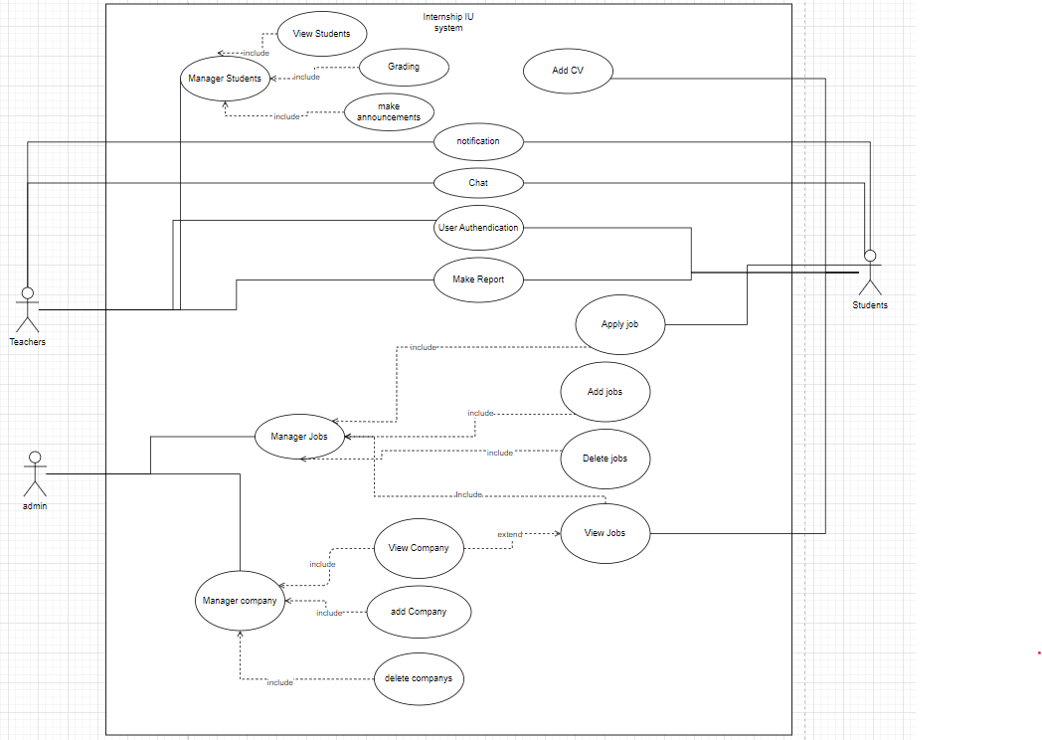

The website will have list of functions:

* Manager Students: This is function of Teacher. Manager Students will include:
  + View Students: web display list student
  + Grading: Show form to grading for student
  + Make announcements: form to send announcements for students (it also sends announcements via email)
* Add CV: Make upload file for students to submit their CV.
* Chat: a chat box for students and teacher can communicate.
* User Authentication: Use account provided by school to access.
* Make Report: provide list of templates for students and teacher.
* Manager jobs:
  + Apply job: form apply job and sent mail to recruiter of company.
  + View job: display list card job for student.
  + Add job: add new job follow form to add database.
  + Delete job: remove job out of database.
* Manager company:
  + View Company: a page displays company information.
  + Add company: add company to database.
  + Delete company: remove company out of database.

#### Workflow of Users

In this website have 2 users are teacher and students.

Students’ workflow:

The main purpose of students will be to use the website to search for intern jobs that the school has selected and introduced on the web. Before applying for a job, students must submit a CV. When students apply for a job, they will send their CV and cover letter by email and have it signed by the school. The process of applying for internship jobs will take place according to the company's process. When the job application is successful, students will go to the website to register according to the sample forms. The registration information will be sent to the teacher for confirmation. After being confirmed by the teacher, the internship will take place according to the company's side. When the internship is nearing its end, the school will automatically send a notification to the students to switch to report writing status. Students will send a report to the teacher and finish the internship.

Teacher workflow:

The teacher's main job is to manage students and grade students' internships. Teachers will check students by way and each student's page to see the student's Cv test information, Confirm the student's work when the student has applied for the job. Get Graded Student Report. After the grading is completed, the teacher will write a final report for the school to end the student's internship.

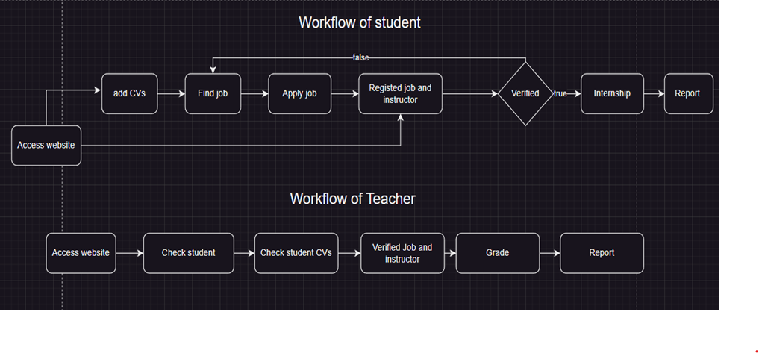

### Database design

# CHAPTER 4

# IMPLEMENT AND RESULTS



## Implement

## Results

A page on users is the authentication page here is a page for students or Teachers will use their account provided by the school to access Internship IU.

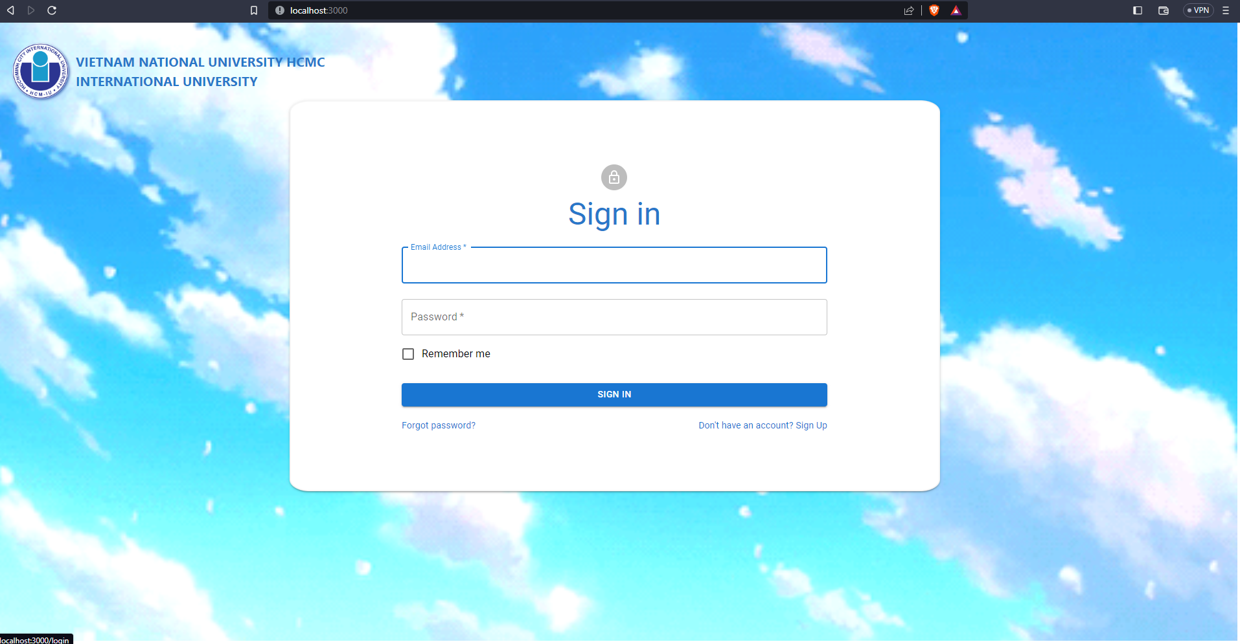

Figure : login page

### Students

This information of the student page will display all critical information about students and show the processed internship of students.

The student's internship process will have 5 statuses: application, job registration, internship, thesis writing, final grading and the end of the internship. The application status is the initial state, only when the student registers the job information as well as the instructor information for the teacher, it will switch to the second state. After being confirmed by the teacher, it will switch to internship status. the fourth state of writing the report will automatically change when the date the school requires the report, and go to the last state when the student submits the report.

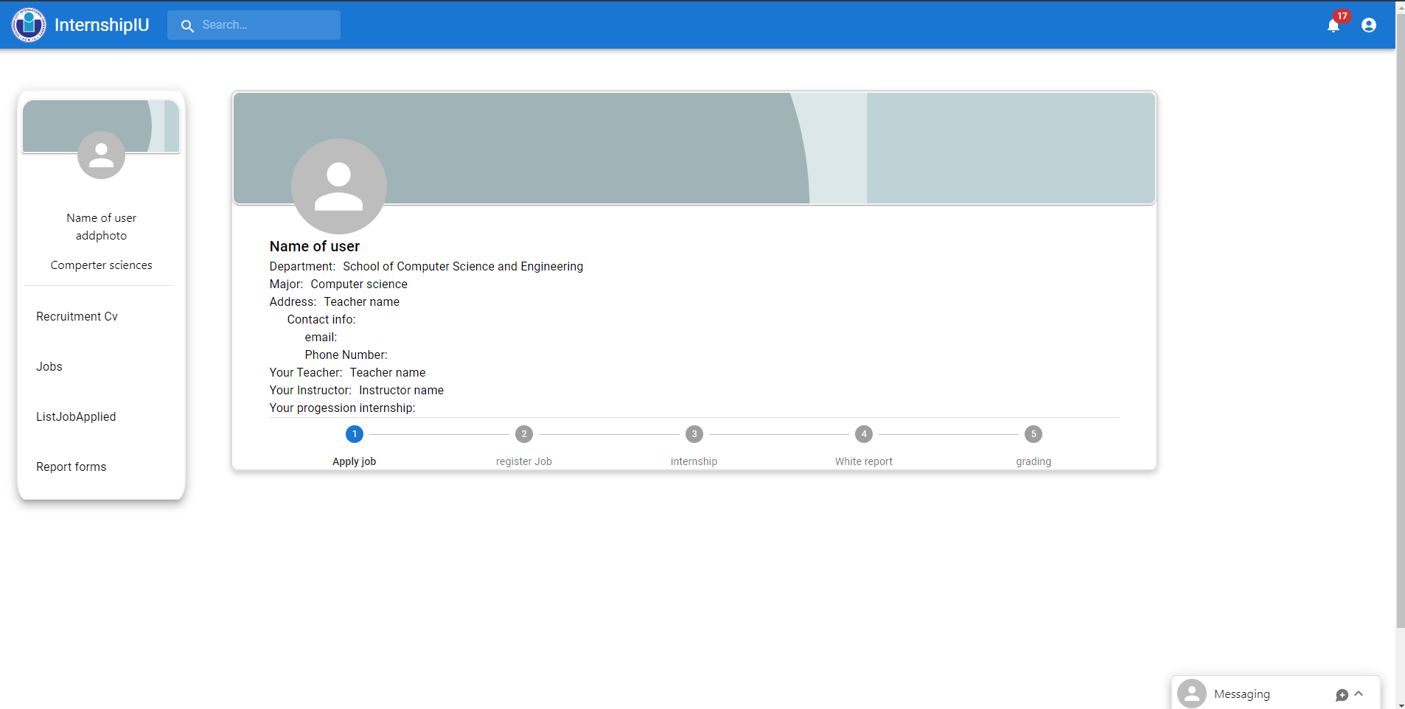

Figure : User information page

Next is the home page of the student role. On this page display list of jobs for students applying. Jobs will display base on Students area of expertise.

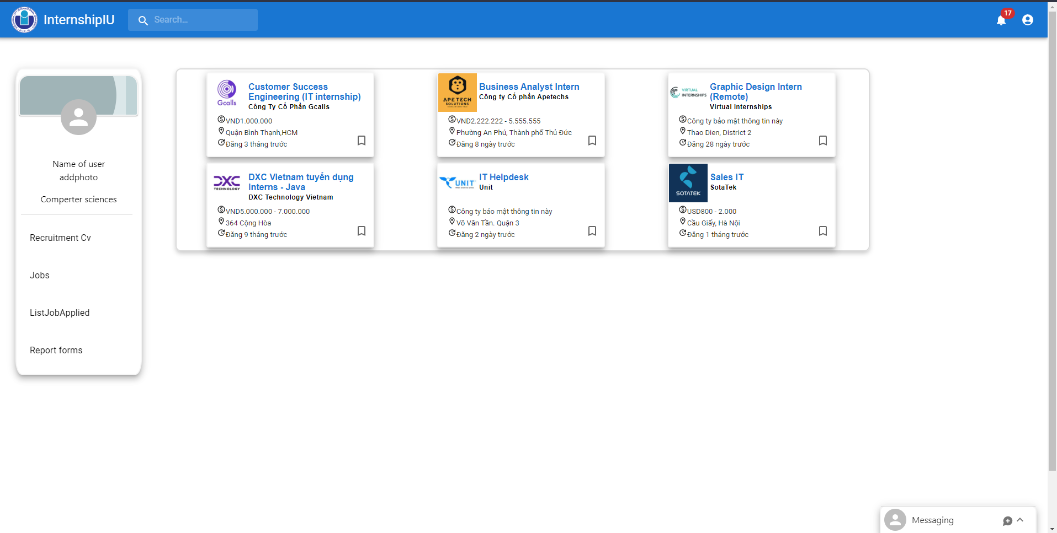

Figure : Home page of students

This modal display details of jobs for students can read and apply for jobs. Modal job will display name, company name, requirement, description, …

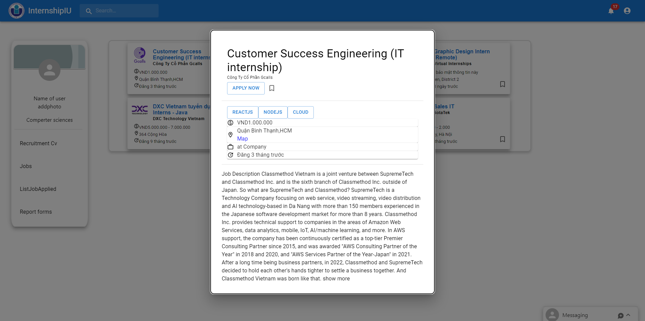

Figure : Modal of job view

When user click title of job in modal job it will redirect to company page.

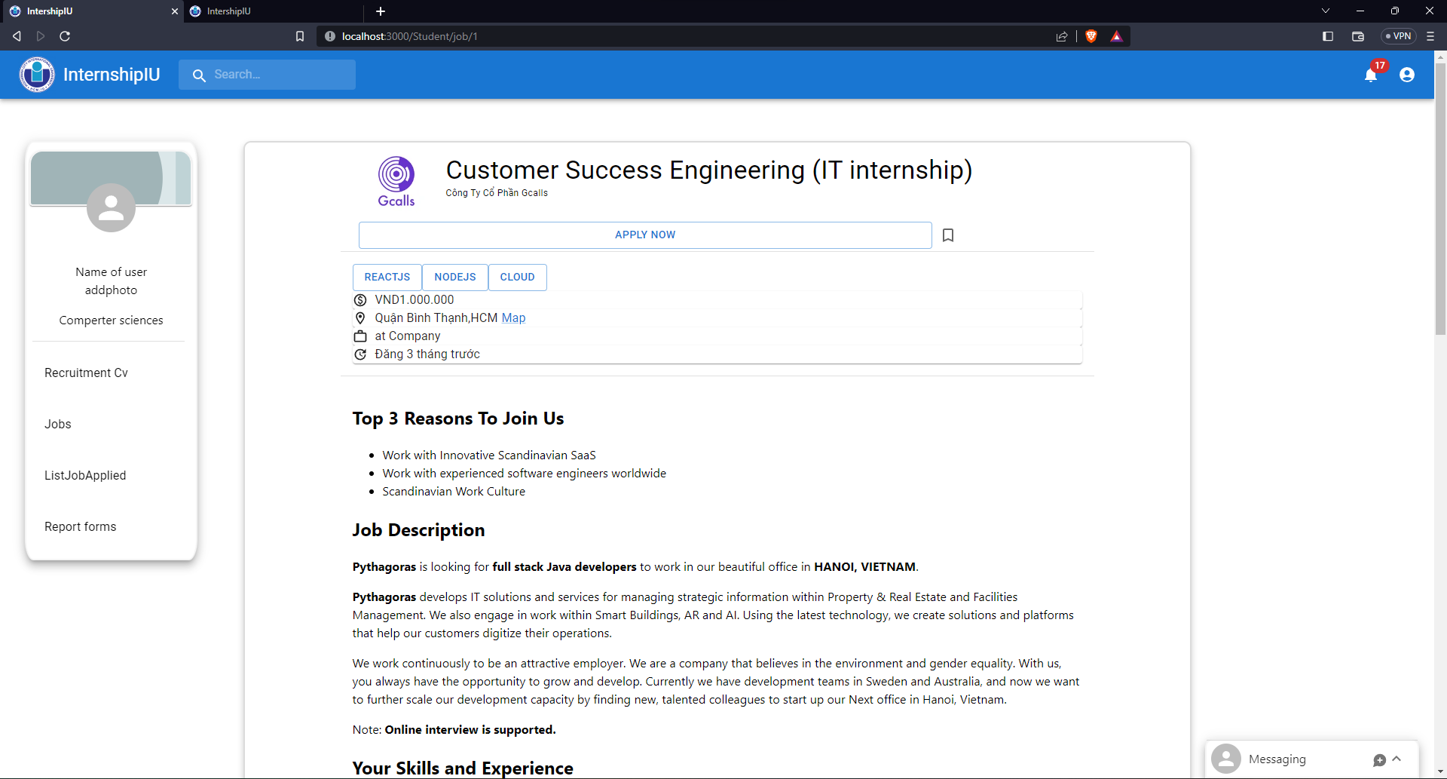

Figure : Jobs page

The website also has a company page for students to view more information about that company and understand what company they apply to.

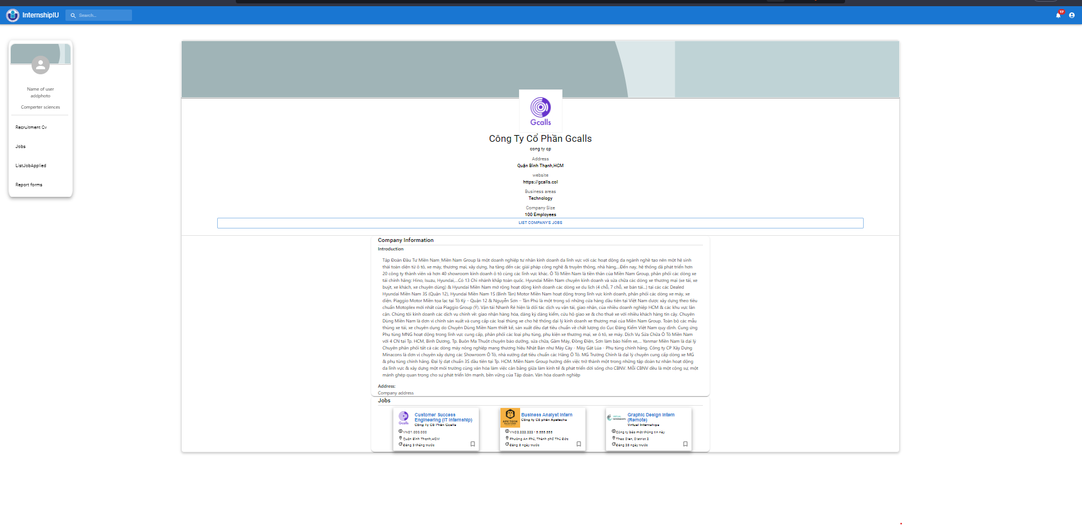

Figure : company page

The application form page will display job and student information will send to the recruiter by mail.

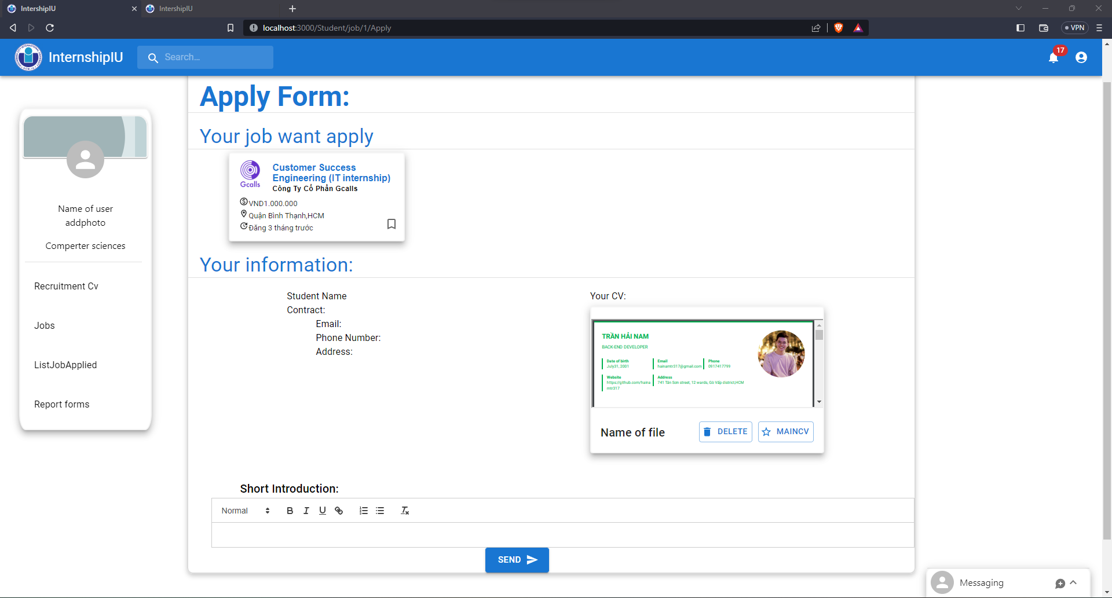

Figure : Apply form.

The jobs applied for will display on the applied page. On this page, students can register their job if they can find a job outside or student receive a job from the Company they apply.

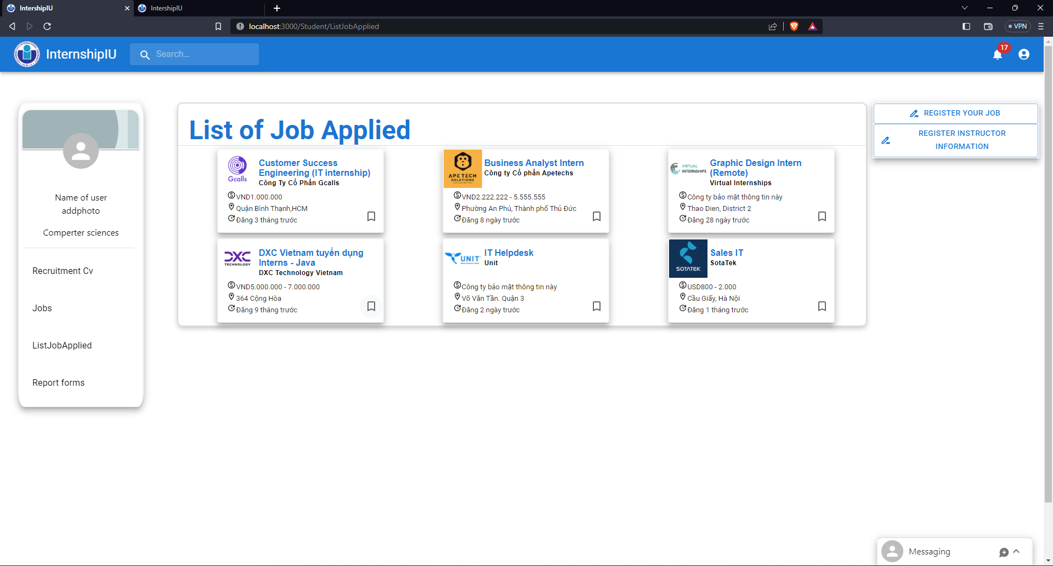

Figure : Display jobs applied page.

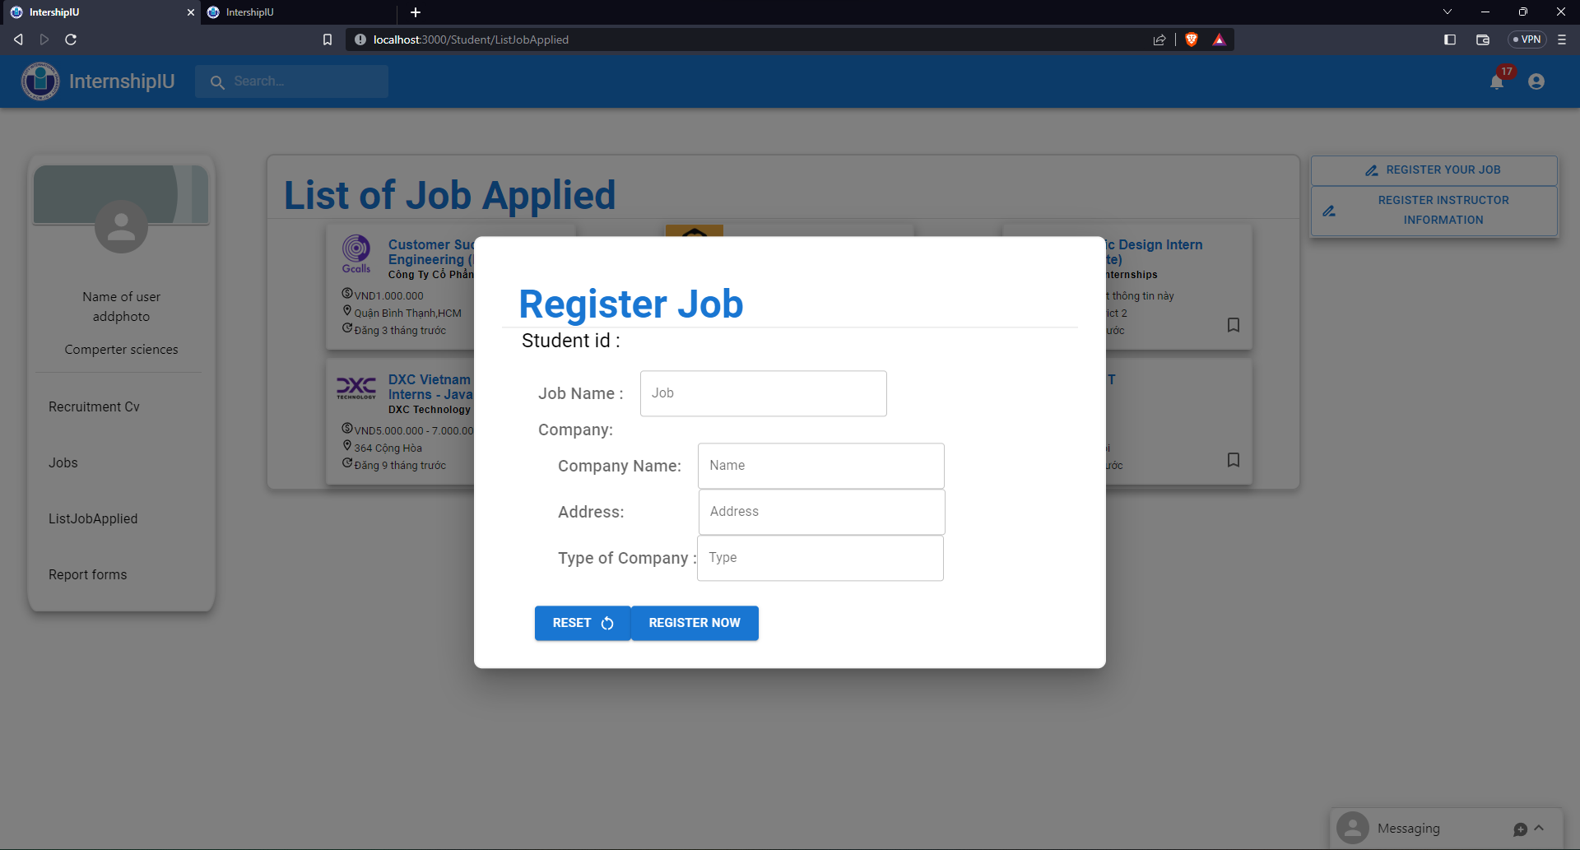

Figure : Register job form

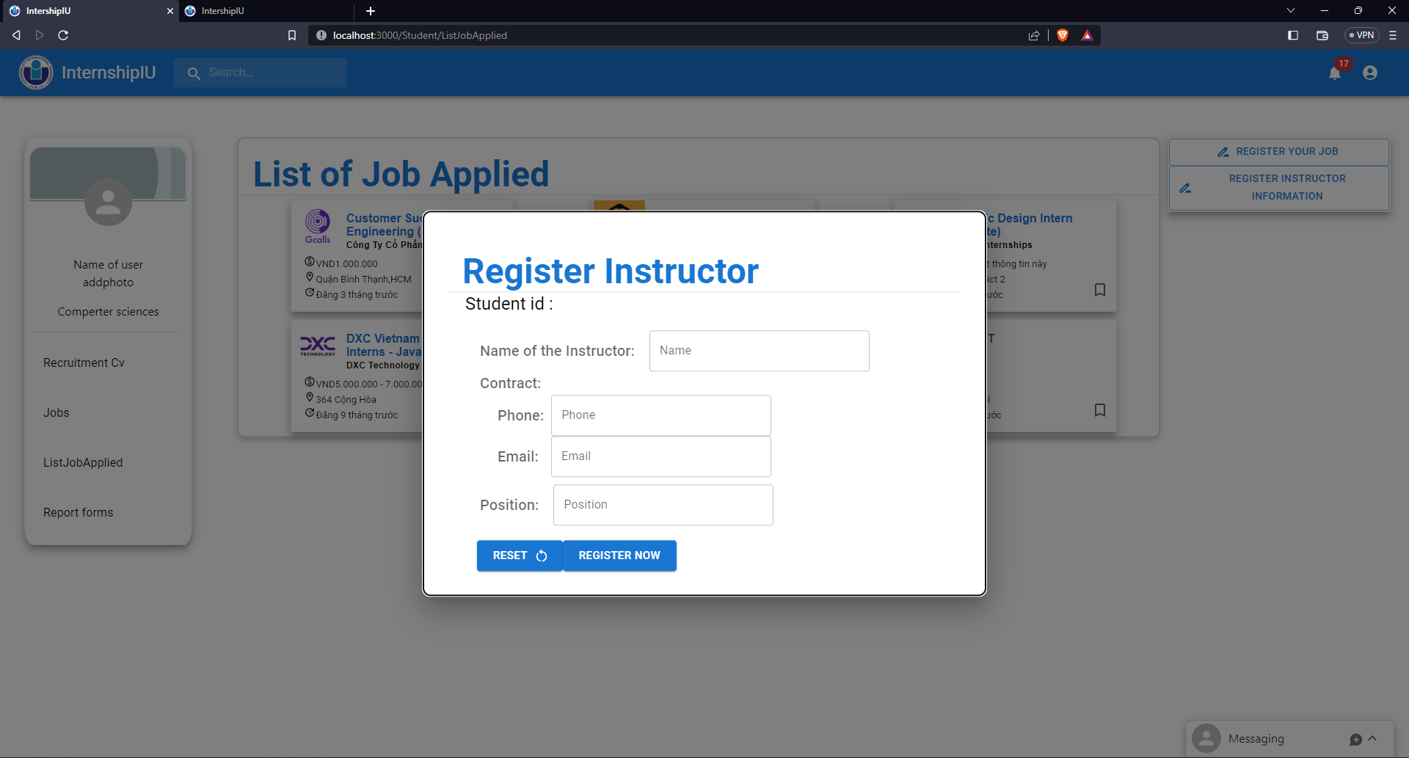

Figure : Register instructor form

After finishing the internship, they can find a report form on this website and submit it through the Internship IU website.

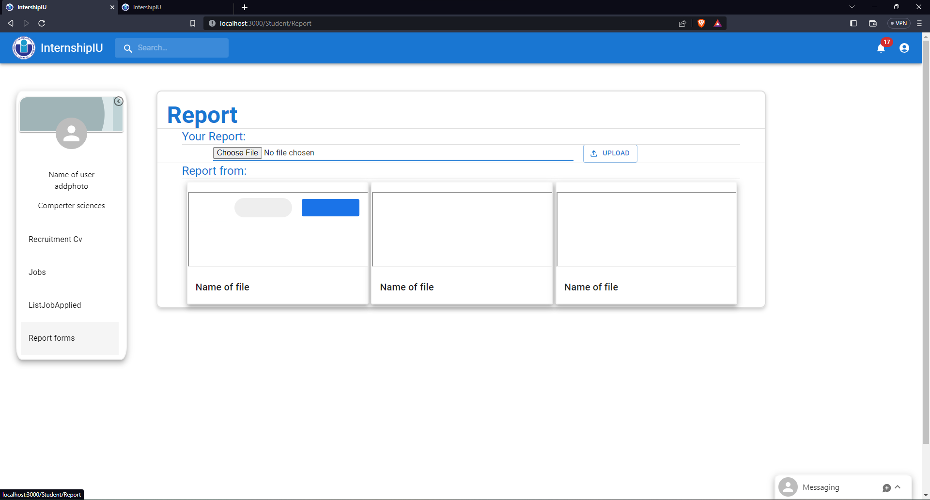

Figure : Report page

### Teacher

Teachers will see a list of students and their managers. On this page, Teach can quickly observe the process of student support immediately.

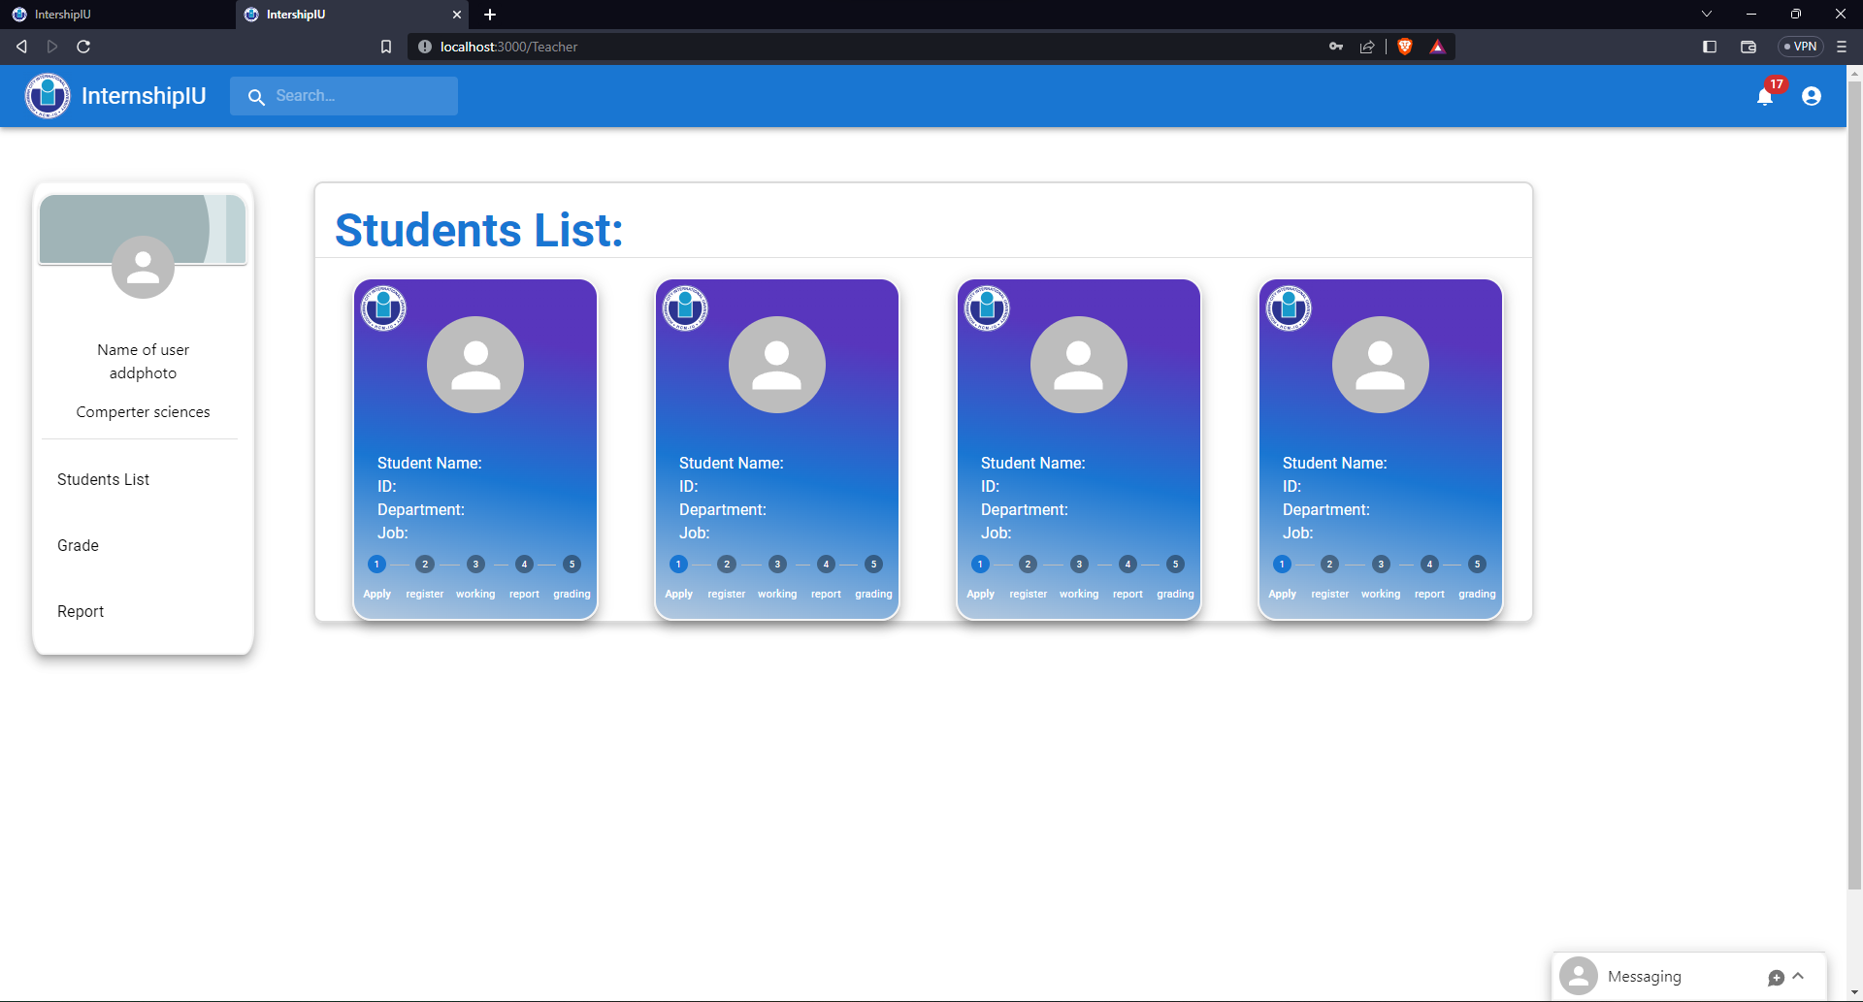

Figure : Home page of Teacher

When clicking on the student card. The web will redirect to the student page to view detail. On this student page, the teacher can grade and make an announcement if students have problems with their CVs or report.

Figure : View Student

Announcement form:

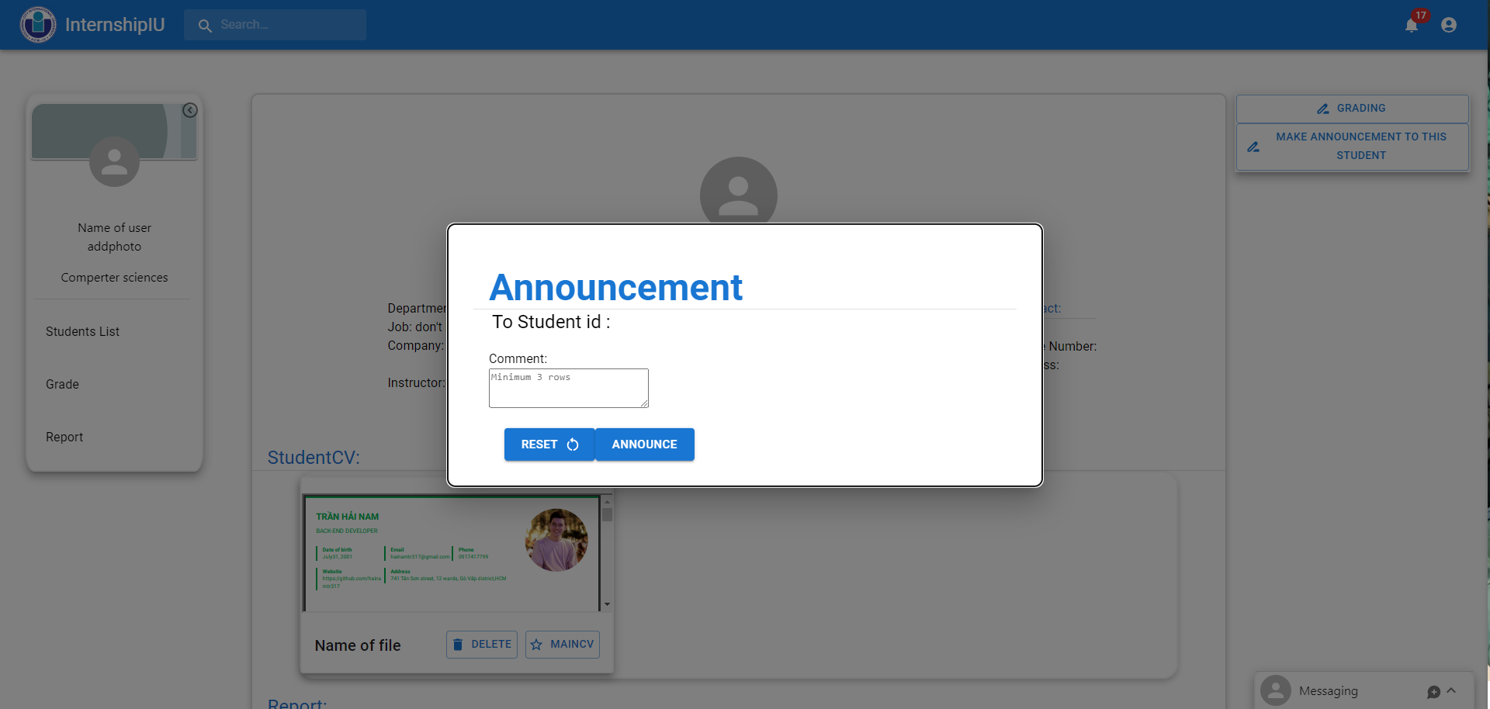

Figure : Announcement form

Grade form

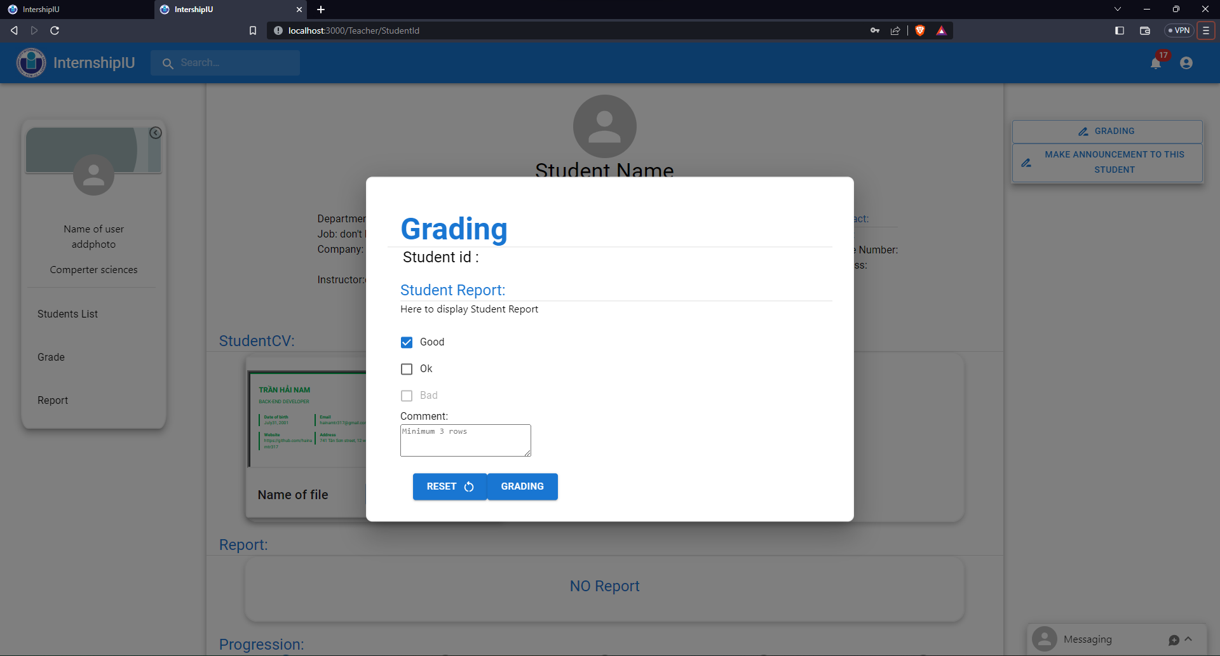

Figure : Grading form

This grade page will display a list of students with their grades, easy for the teacher to observe and modify if the Teacher has a problem. It also can export for teacher can make a report for school later.

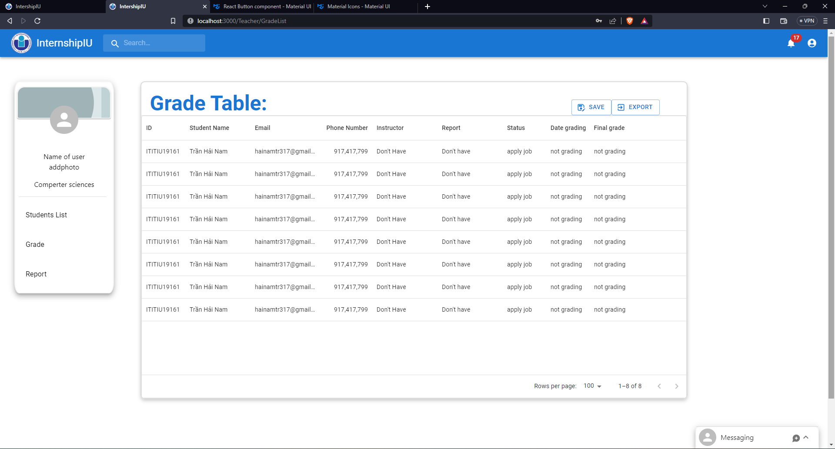

Figure : Grade view page

Teachers can find some report forms on this page and submit them to the school by mail.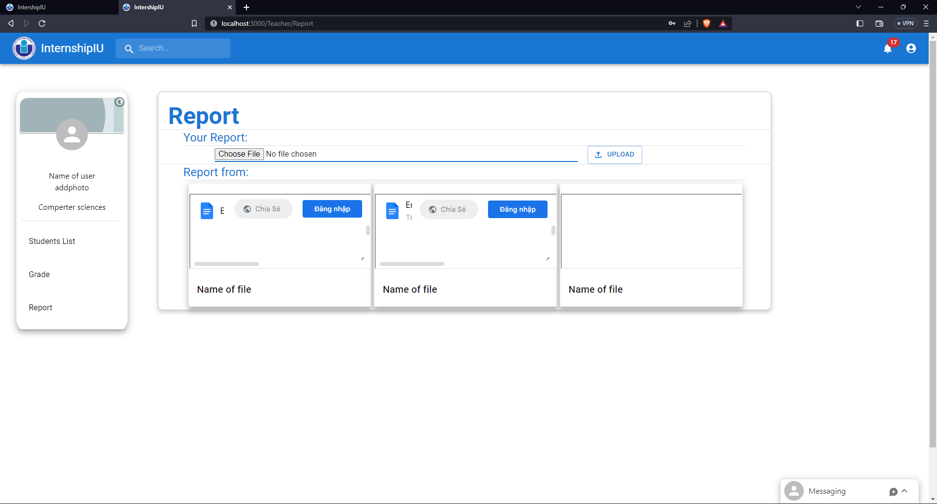

Figure : Report page

### Admin

The admin page will give the admin all the rights to view and modify information for users such as accounts, roles, companies, and even jobs.

Admin will manage 3 main objectives on website are User, Company, and Jobs. Admin's main activity is to add jobs and companies.

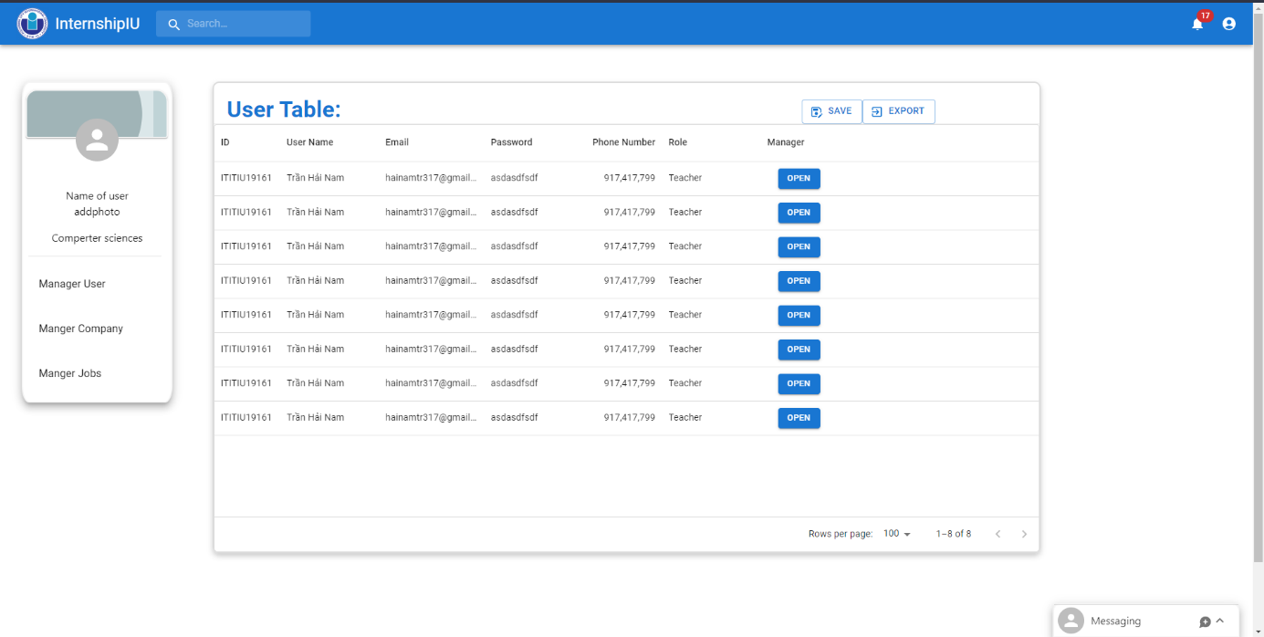

Figure : Manager User

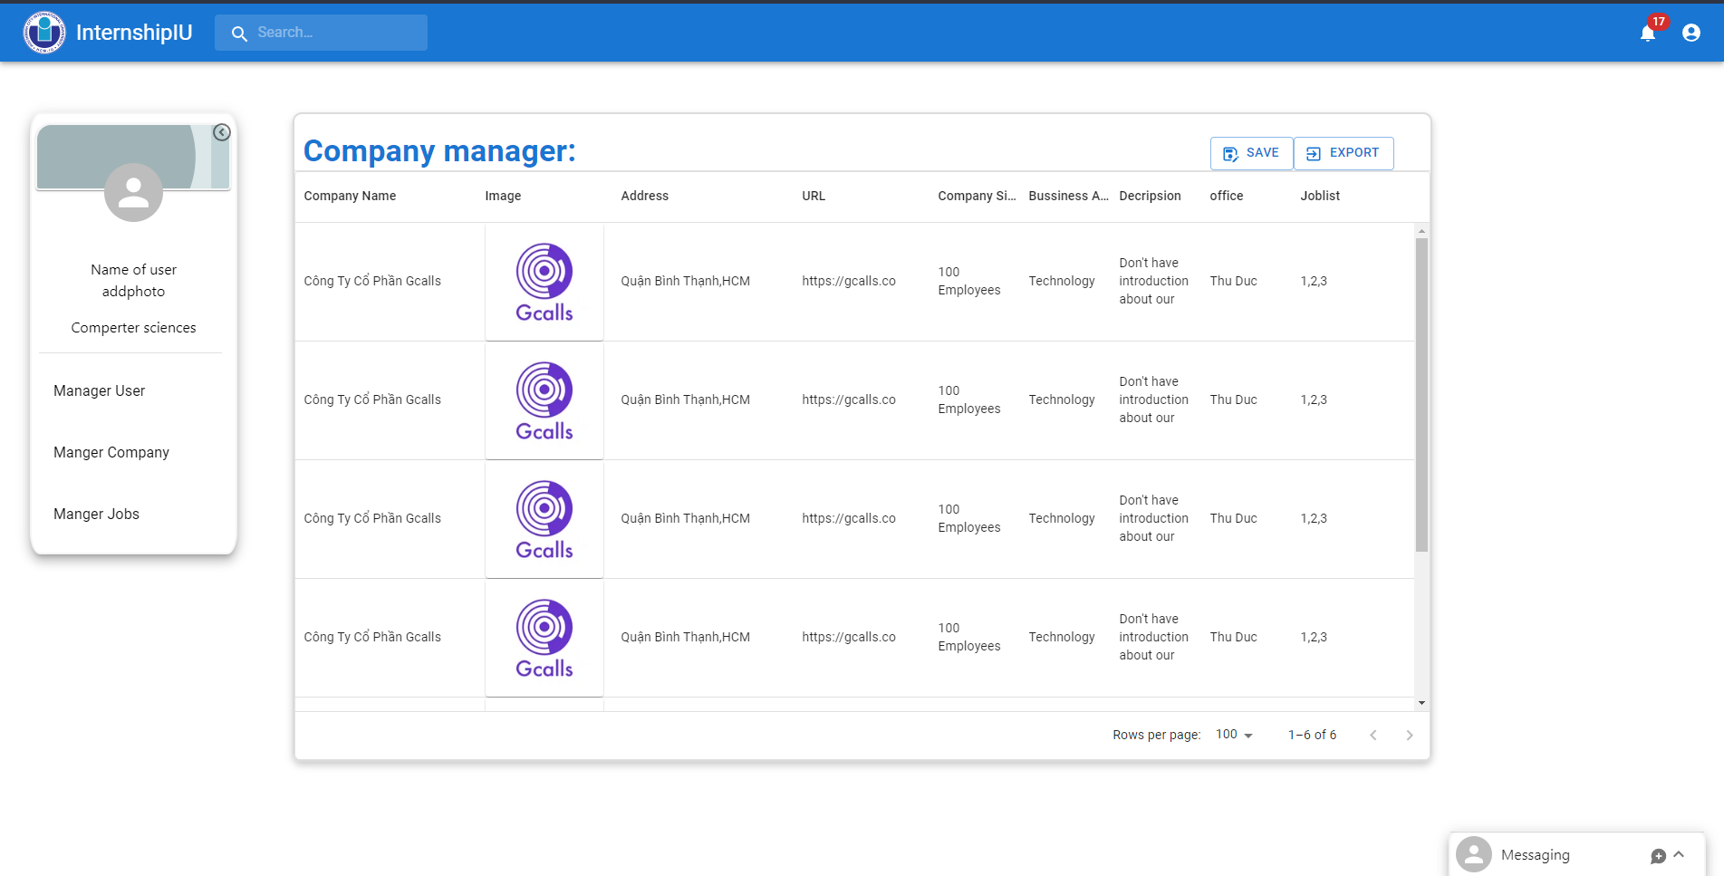

Figure : Manager companies

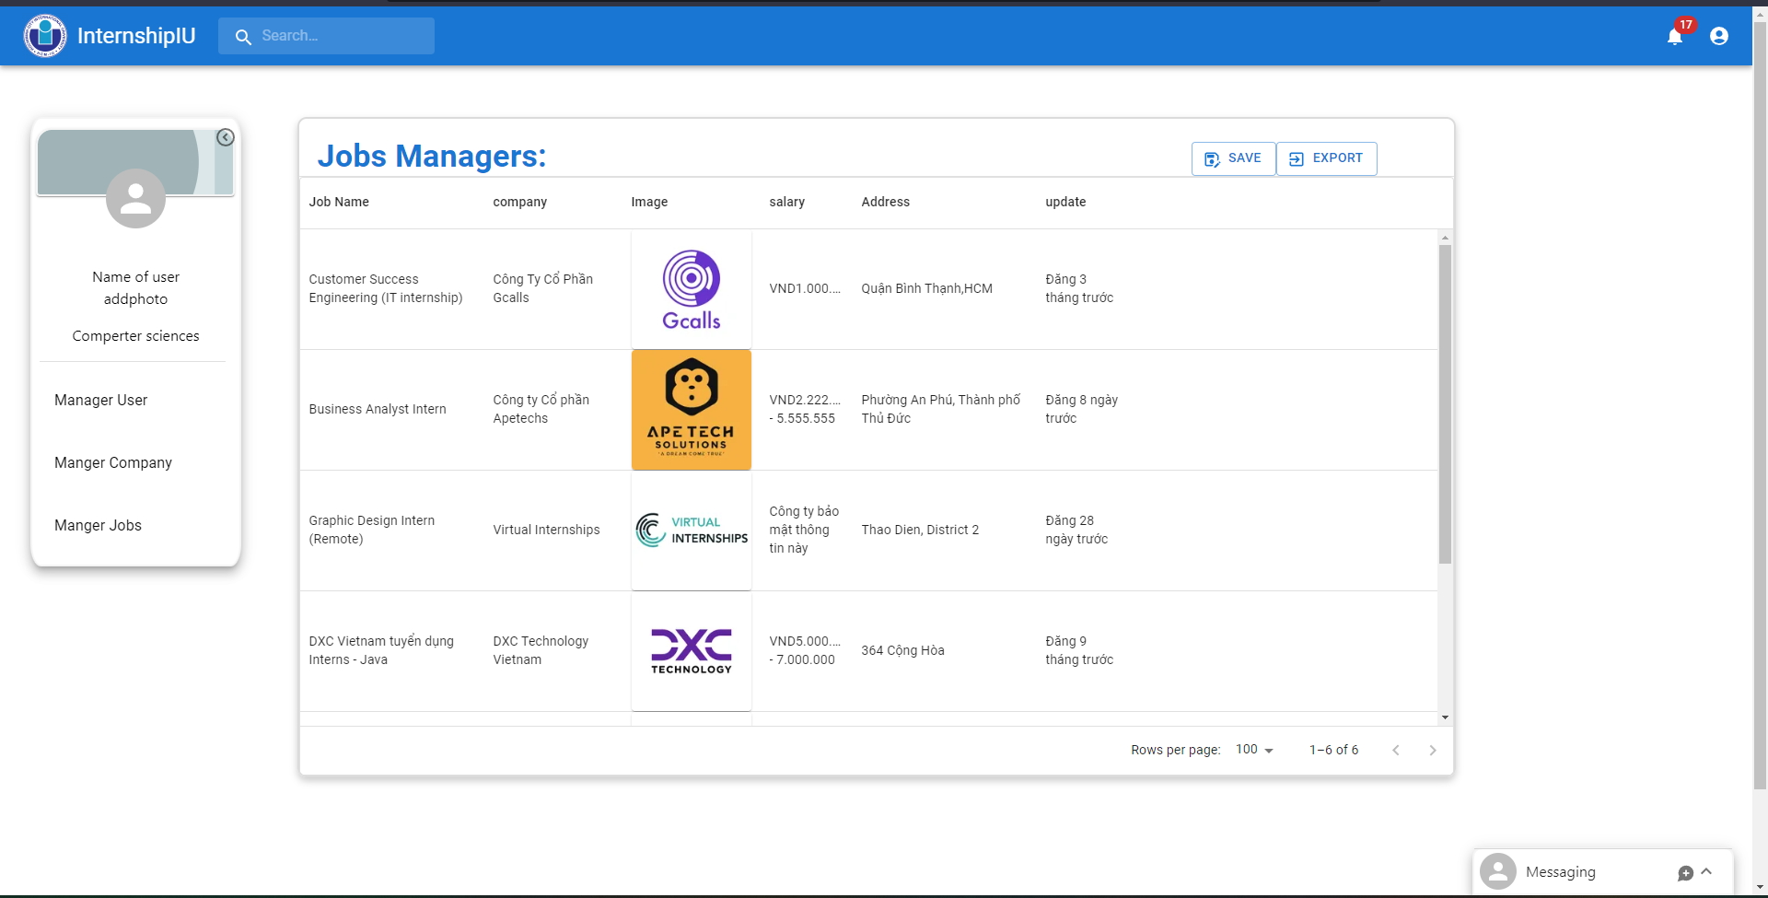

Figure : Manager Jobs

# CHAPTER 5

# DISCUSSION AND EVALUATION



## Discussion

## Comparison

## Evaluation

# CHAPTER 6

# CONCLUSION AND FUTURE WORK



## Conclusion

## Future work

# References

(DSA), S. C. (2023, 12 22). *Làn sóng cắt giảm nhân sự có khiến sinh viên lao đao?* Retrieved from ueh.edu.vn: https://ueh.edu.vn/cuoc-song-ueh/tin-tuc/lan-song-cat-giam-nhan-su-co-khien-sinh-vien-lao-dao-71212?app=true&app=true

glints. (2015). *glints*. Retrieved from glints: https://glints.com/vn/about

Hai G. (2020, March 23). *React là gì? Và nó hoạt động như thế nào?* Retrieved from Hostinger: https://www.hostinger.vn/huong-dan/react-la-gi-va-no-hoat-dong-nhu-the-nao

hamiswillee,Cybersharph . (2023, jun 30). *What is JavaScript?* Retrieved from developer.mozilla.org: https://developer.mozilla.org/en-US/docs/Learn/Getting_started_with_the_web/JavaScript_basics#what_is_javascript

Kononenko, K. (2017, November 3). *Going out to eat and understanding the basics of Express.js*. Retrieved from freecodecamp: https://www.freecodecamp.org/news/going-out-to-eat-and-understanding-the-basics-of-express-js-f034a029fb66

layoffs.fyi. (2023). *layoffs.fyi*. Retrieved from layoffs.fyi: https://layoffs.fyi/

LEADERONOMICS. (2022, 7 1). *5 Pros and Cons About Taking On an Internship as a Student*. Retrieved from leaderonomics: https://www.leaderonomics.com/articles/youth/pros-cons-internship-student

LinkedIn. (2003). *LinkedIn*. Retrieved from LinkedIn: https://www.linkedin.com/company/linkedin/?src=or-search&veh=www.google.com%7Cli-other

Metwalli, S. A. (2023, March 28). *What Is NPM?* Retrieved from builtin: https://builtin.com/software-engineering-perspectives/npm

Poddar, R. (2022, March 24). *What is a JWT? Understanding JSON Web Tokens*. Retrieved from SuperTokens : https://supertokens.com/blog/what-is-jwt

Refine. (2023, May 15). *What is Vite? & Vite vs Webpack*. Retrieved from Refine: https://refine.dev/blog/what-is-vite-vs-webpack/#what-is-vitejs

Semah, B. (2022, December 5). *What Exactly is Node.js? Explained for Beginners*. Retrieved from freecodecamp: https://www.freecodecamp.org/news/what-is-node-js/

Sharma, A. (2023, October 5). *Express JS Tutorial*. Retrieved from simplilearn: https://www.simplilearn.com/tutorials/nodejs-tutorial/what-is-express-js

stackoverflow. (2023, May). *The 2023 Developer Survey*. Retrieved from survey.stackoverflow.co: https://survey.stackoverflow.co/2023/#overview

Tùng, T. T. (2022, 5 6). *antoanthongtin*. Retrieved from Rủi ro bảo mật trong chuyển đổi kỹ thuật số: https://antoanthongtin.vn/hacker-malware/rui-ro-bao-mat-trong-chuyen-doi-ky-thuat-so-108038

Wannakhao, C. (2023, August 4). *5 Reasons Why JavaScript is the World’s Most Popular Programming Language*. Retrieved from trienpont: https://www.trienpont.com/software-development/javascript/

Zhang, L. (2020, 6 19). *Everything You Need to Know About Internships—From What They Are to How to Get One*. Retrieved 2023, from themuse: https://www.themuse.com/advice/what-is-an-internship-definition-advice

My source code

https://github.com/hainamtr317/InternshipIU.git